

South Lanarkshire College

Students’ Association

Board Report

May 2024



Table of Contents
Student Engagement 3
SA Elections 4
Student Poverty 5
Care Day 5
LGBT History Month 6
Climate Action Activity 7
International Women’s Day 8
Easter Activities 8
Forthcoming Events 9
Mental Health Awareness 9

Student Engagement

It continues to be a very busy time for the SA. We’ve celebrated Care Day, Love Your Planet, LGBT History Month, Purple Friday and arranged many more activities!
The Gradu8 Creative and Digital Media class designed badges for the SA as part of a class activity. It was great to see all their creative ideas! We had a chance to meet some of these students and got to see all the work that they had done in their class. Their designs were wonderful, and they deserve great praise for these.
The Student Association set up a stall to promote the BRIT Challenge Bingo Card, along with the College’s free yoga classes. We have a large supply of yoga mats which are provided to students who sign up for yoga. The BRIT Challenge is now officially over and finished on March 24.
Before the Easter break, the SA set up a stall where we gave out holiday packs containing pads and tampons, reusable pads, and menstrual cups. We do this before every holiday to make sure that students have access to sanitary products at times that they are not on campus. It also gave us an opportunity to talk about sustainable products.
We have been working very closely with Anne Doherty as part of our Climate Action activity, further details of this are included later in this report. We would like to thank Anne for all her support regarding this activity! Part of this work included organising a litter picking event, information stalls and visits to Whitelee Windfarm. We have already taken one class and plan to take more class groups to the windfarm, where they provide a workshop and a bus tour.
The SA continue to have students come to us with their ideas and suggestions. We have made it a priority to make sure that we try and fulfil these requests from our students. For example, one student came to us with the idea of selfcare kits containing a selfcare timetable or checklist. We have now taken this into consideration and plan on giving these out for Mental Health Awareness Week.

SA Elections


The promotion of the SA elections for AY 2024/25 is now fully underway. We have promoted the elections through the student newsletter, social media, emails to all Curriculum Areas, and various Teams Channels, including the Class Reps channel. The timeline for elections has been promoted to both staff and students and is outlined below.

- Monday 11th March – Friday 22nd March: Advertising.
SLC to promote election to all current students. If you would like to nominate yourself for the President or Vice President, see Nominations info below.

- Monday 25th March – Friday 26th April: Nominations Open.
Nomination packs will be available from 25 March (on the SLC website and on request from Karen Pirie). Packs must be completed and submitted no later than Friday 26 April.

- Tuesday 30th April: Candidates Briefing.
Candidates must attend the briefing where they will be given information on how the election will be run and how they can campaign for votes.

- Wednesday 1st May – Wednesday 15th May: Voting.
Voting will take place online on Moodle, and all students will have one vote for their preferred candidates.

- Thursday 16th May: Checking and Counting.
SLC Staff will check and count all votes.

- Friday 17th May: Results.
Results will be announced.

The deadline for nomination packs is Friday 26th April. The current SA President and SA Vice President look forward to working with the College to ensure a smooth handover to the incoming SA for 2024/25.

We wish good luck to all candidates!

Student Poverty

The Student’s Association is committed to tackling student poverty. We continue to ensure our students are fully supported during the current cost of living crisis by providing free soup and sandwich, as well as a healthy breakfast. We rotate this on a weekly basis to make sure that all our students have access to this initiative. Student uptake of this has continued to be very positive with over 3,000 servings to date. Going forward we will be expanding breakfast provision to two servings per week and will be increasing promotion of this invaluable service.

In addition, the SA continue to operate a food larder directly from our office where students can take what they need at any time. This is stocked with non-perishable foods, hygiene products, sanitary products, and stationery. We have also received many generous donations. We are increasing the quantity of orders to ensure students are well supported by the SA Larder.

We would like to express our sincere thanks to the SLC Trust for further funding of this initiative. This will allow us to provide crucial support to students for the remainder of this year and into the next academic year. The SA and our whole team are extremely grateful for this, and we know the students benefit greatly. We are also taking further steps to bolster our larder stock by contacting local companies and supermarkets to ask if they can make donations to the food larder for our students.

The SA are in the process of writing an article on Student Poverty for Think Positive, which will be posted on the Think Positive Hub. In the article we will provide detail on all our initiatives, as well as the College Way Market, to highlight the College’s dedication to supporting students during this cost-of-living crisis. This work will be promoted as part of the Student Mental Health Agreement. We look forward to promoting this to students.

Care Day

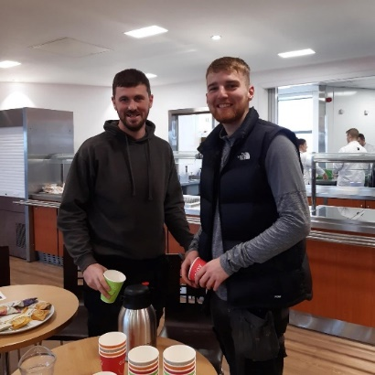
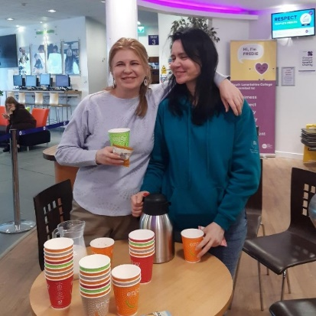
Care Day took place on 16 February and it’s the world’s biggest celebration of people with care experience. At the College, we celebrated Care Day by hosting a free hot chocolate and cookie event, arranged student reviews of our Corporate Parenting Plan and one of our teaching staff, Kelly McKenzie, created an article providing an overview of the day and highlighting our responsibilities as Corporate Parents. The College also created a Care Day 2024 SLC Pledge for staff to sign to show their support.

We promoted this activity on our social media channels and newsletters to highlight as much awareness as possible, as well as encouraging students to go along to the event. It was great seeing so many people take part on the day in support of our care experienced students.

LGBT History Month

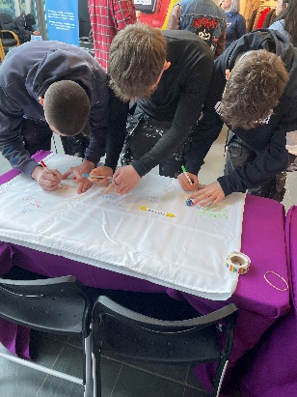
February is LGBT History Month and on 23 February, the SA and Student Services hosted a Purple Friday Event. Women’s Aid, Terence Higgins Trust, and Breathing Space were all in attendance volunteering at our event. We had our own stall where we handed out rainbow gym bags, pride stickers, rainbow laces, pride face paint, pride flags and LGBT button badges.

The SA also had a tablecloth where many students signed their name in solidarity of the LGBTQ+ community. We would also like to thank our Painting and Decorating Department for creating a LGBTQ+ themed selfie frame.

For this event, our Hair and Beauty Department supplied purple nail painting and hair tinsel. Our Hospitality and Events Department also supplied the students with cakes.

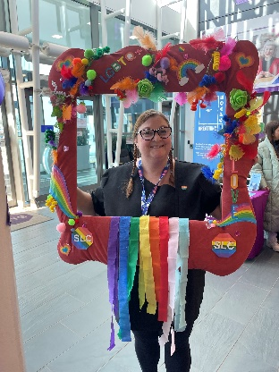
We are incredibly grateful to everyone who helped with such a successful event.

On Thursday 22 February the SA hosted Pride Stride. This was led by our Student Officer Maureen McMullan.
We kept a small supply of our freebies for this. We were so happy to see so many students participating. Stella and Angela met with us beforehand to send us off. This was a great opportunity for students to get to know the SA along with the principalship.

We will promote similar free products and activities for Pride Month in June.

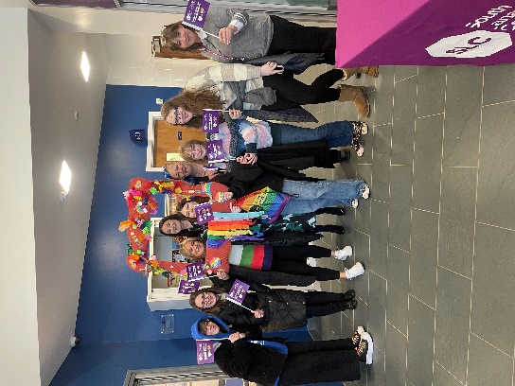

Climate Action Activity


Our ‘Love your Planet’ event was an immense success. The SA gave out reusable water bottles and sustainable notebooks. We also had a recycling game where students would test their knowledge of what goes in certain bins. For this event we received freebies from the Co-op and South Lanarkshire Council to give away to students. Climate Fresk were in attendance giving out “accidently vegan” sweets and showcasing their workshop. Horticulture Students also had a stall where they displayed compostable foods and different environmentally friendly plants. A huge thank you goes out to everyone who was involved in the event.

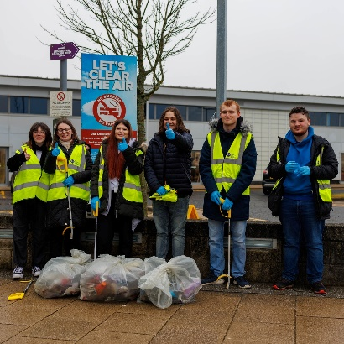
On this day we also held a voluntary litter picking event. So many students came to volunteer, and we managed to collect four full bags of rubbish. We took photos of this and posted it on our social media to promote recycling to our students.

We would like to thank Facilities and Building Supervisors for providing PPE and a safety briefing for our students. We’re also delighted to announce that vape recycling bins are now available on campus.

We redesigned and displayed the College’s Recycling Poster to highlight to students what they should be recycling.

The SA have been organising visits to Whitelee Windfarm for students. So far, we have had one successful visit and are in the process of planning more. This has been made possible due to the funding we generously received from Lanarkshire Climate Action Hub.
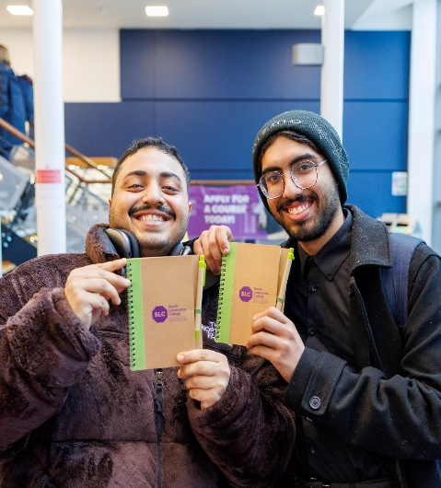
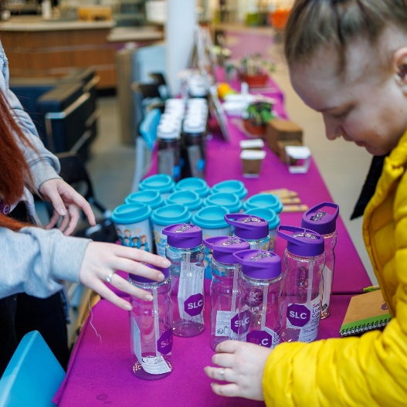

International Women’s Day
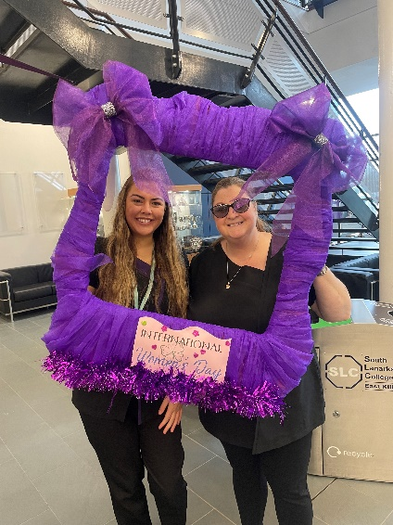
On Friday 8 March it was International Women’s Day. This holiday is celebrated annually as a focal point in the women’s rights movement. The theme for this year was ‘Inspire Inclusion.’

For International Women’s Day the Painting and Decorating Department kindly made us a beautiful selfie frame. The SA then went around campus getting photos of students and staff to celebrate this day. We gave out purple heart stickers as well.

It was so great to see everyone’s positivity towards this.

Easter Activities

For Easter, the Student Association hosted an Easter egg hunt. We hide paper eggs around the Atrium and Advice Centre with notes telling students to take a photo of each of the eggs to collect their prize from the SA Office. We had a fantastic amount of student engagement from this and ended up running out of easter eggs!

This was a fun activity for our students to take part in before finishing for the Spring Break.




Forthcoming Events

Mental Health Awareness

Mental Health Awareness Week, now in its 24th year, runs from 13-19 May and is hosted by the charity, Mental Health Foundation. We hope to create and hand out selfcare kits to our students during this week.
These packs may contain:
- selfcare checklist
- pen
- mindfulness colouring
- facemask
- eye mask
- healthy recipes with dairy free, gluten free and vegan options
- mental health information
- stress ball

We will be working with students to see what they would like to have in these selfcare packs by asking for their opinion via social media and verbal communication.

The idea for these selfcare packs came directly from a student. We believe this is an amazing idea and a good opportunity to make better connections with our students.

During this event we will also promote our yoga and mindfulness classes, as well as available support in the College.

The theme for Mental Health Awareness Week is ‘Movement: Moving more for our mental health.’ We hope for our weekly wellbeing walks to continue throughout the remainder of the academic year. This will also be promoted at the stall.

