

South Lanarkshire College

Students’ Association

Board Report

October 2024



Contents

Student Engagement 3
Freshers’ Week 4
Free Soup & Sandwich/Free Breakfast 7
Student Officer Elections 8
Student Mental Health Agreement (SMHA) 8
STEM Event – Wednesday 9 October 8
World Mental Health Day – Thursday 10 October 9
Litter Picking Event and General Activities 10
EmilyTest Charter 11
Forthcoming Events 11

Student Engagement

The Student Association have had a busy few months from welcoming lecturers back on 9 August, followed by welcoming our students returning for the academic year 2024/25 on 26 August. The SA President and Vice President began class visits immediately as it was agreed this would be the best way to meet as many students as possible. To date there has been a total of 56 class visits at the time of this report. Feedback received to date has been overwhelmingly positive. The SA will continue with class visits, with a focus on organising more for the January start classes.

We hosted our Freshers’ Event on Monday 9 September to Wednesday 11 September with the theme of making connections. The event was a fantastic success with students engaging with the SA stall, as well as all the different exhibitors who attended. In keeping with our vision of encouraging students to make connections we organised further events including a mental health event on World Mental Health Day and a Litter Picking event just after Freshers’. Both the SA President and Vice President were also delighted to be involved in planning for the STEM event on Wednesday 9 October, as well as being Student Ambassadors!

Student Elections have taken place, and we are delighted to welcome seven new Student Officers to the SA. We look forward to working with them to continue with our commitments for the year and to see what initiatives and activities they would like to introduce to the SA and the College.

It’s going to be a busy year for the SA with lots of events and activities planned, with the next one being our Halloween Best Costume competition. We have already made a lot of connections with students in the last few months and can’t wait to build on this throughout the rest of the academic year.

Freshers’ Week



Monday 9 – Wednesday 11 September

Freshers was a brilliant experience for the Student Association to host and the students provided positive feedback on their experience of the week. Our theme for this year was Connections, with the SA President even building the Connect4 Photobooth themselves! The photobooth provided a great talking point and students really enjoyed having their photo taken with it. Other activities included our Norma the Gnome Scavenger Hunt with clues hidden around campus to help students familiarise themselves with the College, a Guess What’s in the Box activity and a Guess How Many Sweets in the Jar game. We also had Prize Pong and plenty of freebies for students to enjoy. We would like to say a particular thank you to Aramark for donating juice and crisps for our students. We would also like to say thank you to Tunnocks, Black Rooster and Nando’s for providing free products and vouchers, they were very much appreciated by our students.

There was a fantastic range of exhibitors invited on campus throughout the week including organisations such as Citizens Advice Bureau, Police Scotland, Covey Befriending, Capital Hair and Beauty, Nuffield Health Gym and many more. The stalls were constantly busy, and students were able to speak with a variety of organisations each day. The schedule for the three days is included below. We would like to thank all the organisations to taking time out of their busy schedules to come along and meet our students.

Freshers’ Week wouldn’t be the same without our popular SLCSA hoodies going on sale. As with previous years, the hoodies have been extremely popular with only 14 of them left to sell. The SA is grateful that we can continue to offer them as they provide warm, quality clothing at the affordable price of only £5! We decided to keep the same design as previous years but changed the colours to black, violet, pink and teal. Providing hoodies to our students helps us continue to tackle student poverty, which remains a real issue that many of our students are facing.

The SA were also keen to ensure our evening students felt included, so we arranged to keep some freebies, activities and hoodies available for both the Tuesday and Thursday evening classes. This was really appreciated by our evening students who came over and chatted to us at our stall in the Atrium. It was great to make a connection with these students so they know more about the SA and how to get in touch with us if they have any questions/concerns they would like to raise. Overall, the event was a great success, and we are already looking forward to planning for Refreshers’ in January!

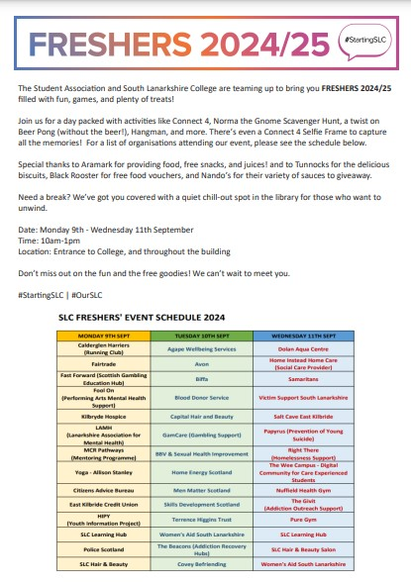






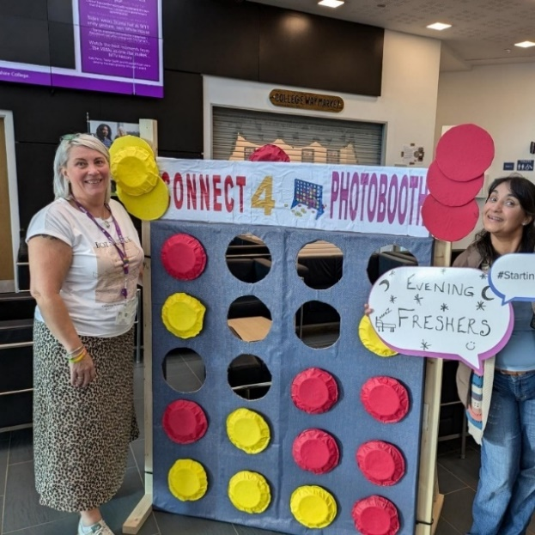
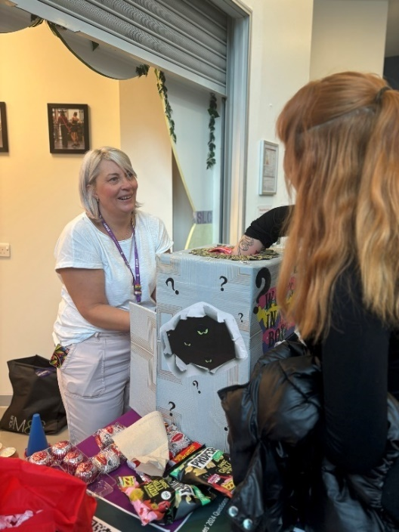
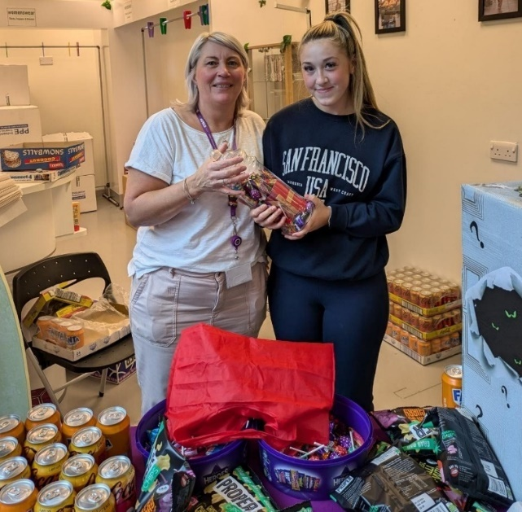
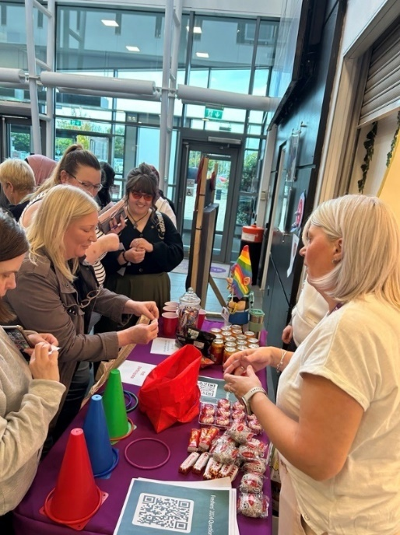

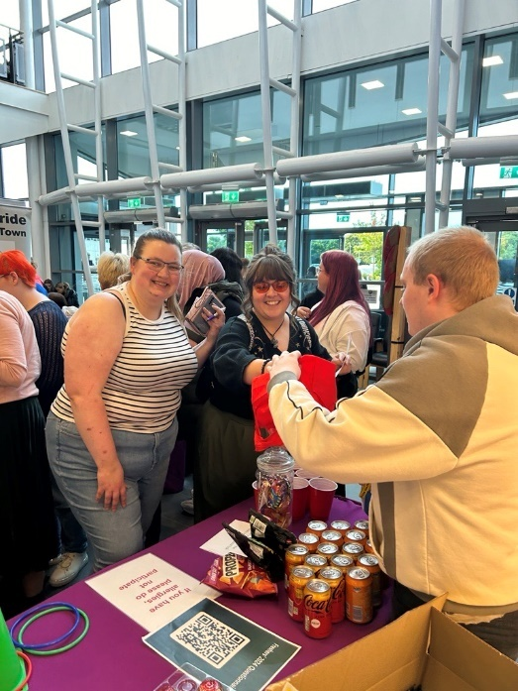
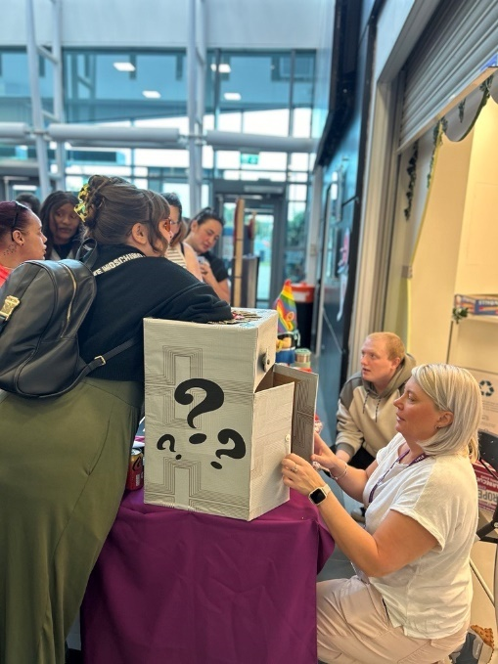

Free Soup & Sandwich/Free Breakfast

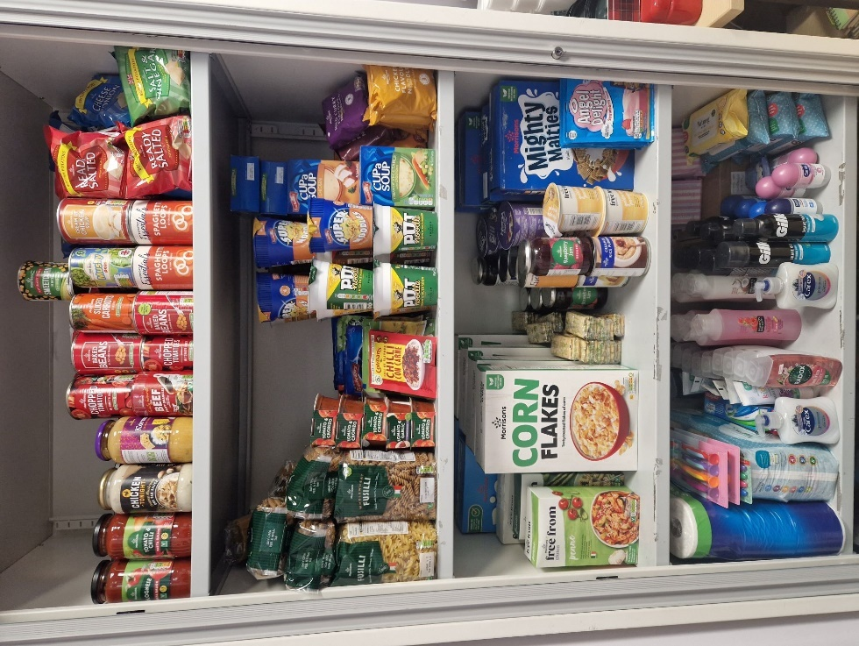
The ongoing cost of living crisis is still greatly impacting our students, and the Student Association is committed to helping them through this challenging time. We are very grateful to be able to continue to provide free healthy breakfasts and free soup and sandwich, with the financial support of the South Lanarkshire College Foundation, to our students. The SA looks forward to working with our new supplier Aramark to continue delivering this important initiative to our students on selected days each week.

We are also committed to continuing with our food larder for students as it has provided a lifeline to some of our students facing financial distress. They know they can access this much needed service by visiting the SA office whenever they need to. Located within the Student Association Office students can come in anytime and take whatever they need, including food and toiletries. In the larder, we also provide free stationary such as notebooks and binders.

Reminders of how to access both initiatives are shared across our social media channels, SA newsletter and on physical posters across campus.



Student Officer Elections

We recently held elections for Student Officers which make up the wider SA Executive team. We are delighted to announce that seven students applied for the role of Student Officers, with all the candidates now having been voted in by students. We are currently planning our first Executive Committee meeting in the next few weeks to discuss their availability, areas of responsibility and ideas that they may have.

Also, at this time of the academic year, discussions are underway with Course Tutors and their class groups to appoint a Class Representative. This is a key role and provides students with a strong voice to help contribute to decisions that can positively impact learning and teaching and the student experience. The Quality team, who oversee the Class Reps have a designated Teams page to support the Class Rep process. To ensure we continue to work in close partnership with Class Reps the SA have a dedicated SA channel within the Teams page. We are looking forward to attending the forthcoming Class Rep training and supporting the Class Reps in their role.

Student Mental Health Agreement (SMHA)

The College and Student Association have both committed to signing up for the Student Mental Health Agreement in 2024, with a view to undertaking a further 2-year plan on how to best support student mental health.

The Student Mental Health Agreement is an initiative by Think Positive with the focus being to improve and promote student mental health support across Scotland. A great deal of work has taken place over the last few years in partnership with Think Positive, with three key aims being the focus of the 2022-2024. We will review these key aims, and with the input of our student body, will agree on what our key aims will be for 2024 onwards.

Upcoming meetings are due to take place with Think Positive over the coming weeks to discuss next steps for driving this initiative forward.

STEM Event – Wednesday 9 October

The SA was delighted to take part in the annual STEM event at the College. Organised in partnership with DYW, we enjoyed being part of the weekly planning meetings to ensure the event was another great success. The event took place on 9 October and involved inviting over 150 pupils, 14 teachers, and 38 employers (including 82 delegates) on campus! The atmosphere in the building was fantastic and involved a huge cross-college effort.

Both the SA President and Vice President took part on the day as Student Ambassadors with duties involving organising the buses arriving during the morning, welcoming pupils, teachers and exhibitors, showing pupils and teachers around all the workshops and marketplace, before assisting them back to their school bus.
We would like to say a huge thank you to all our wonderful Student Ambassadors. We had over 20 student volunteers taking part in the event to ensure the pupils and teachers had a great time. Many of our student volunteers were from STEM subjects so they also had the chance to speak with the exhibitors, as well as tell pupils about what it’s like to study STEM at SLC. The day wouldn’t be able to go ahead without our student volunteers and they all did a great job! The feedback we have received from schools and exhibitors so far has been very positive with particular mention being made of receiving a warm welcome from SLC staff and Student Ambassadors. We will be arranging a thank you event for them where each student will receive a certificate from SLC and a voucher from DYW.

World Mental Health Day – Thursday 10 October

The SA hosted an informal chat session to highlight World Mental Health Day. Students were invited along to The Bistro over lunchtime for snacks and drinks. Our speaker, fellow student Ross, got the chat going with an introductory talk showing his passion for talking about mental health. There were various information and support leaflets with ideas on how to spot stress triggers and signs and ways to manage these. A member of the Guidance and Support team was also in attendance to highlight about the College’s counselling and support services. Ice-breakers were a lot of fun and helped get everyone relaxed and in the mood for a chat.

To continue to support student mental health, the SA is organising a Monday Mindfulness Lunchtime Colouring Club running from 21 Oct until 16 Dec. Located in the Library Group Study Room, we will be providing a space for mindfulness and support. Activities will also be provided with wordsearches, word jumbles and colouring books and pencils being made available.

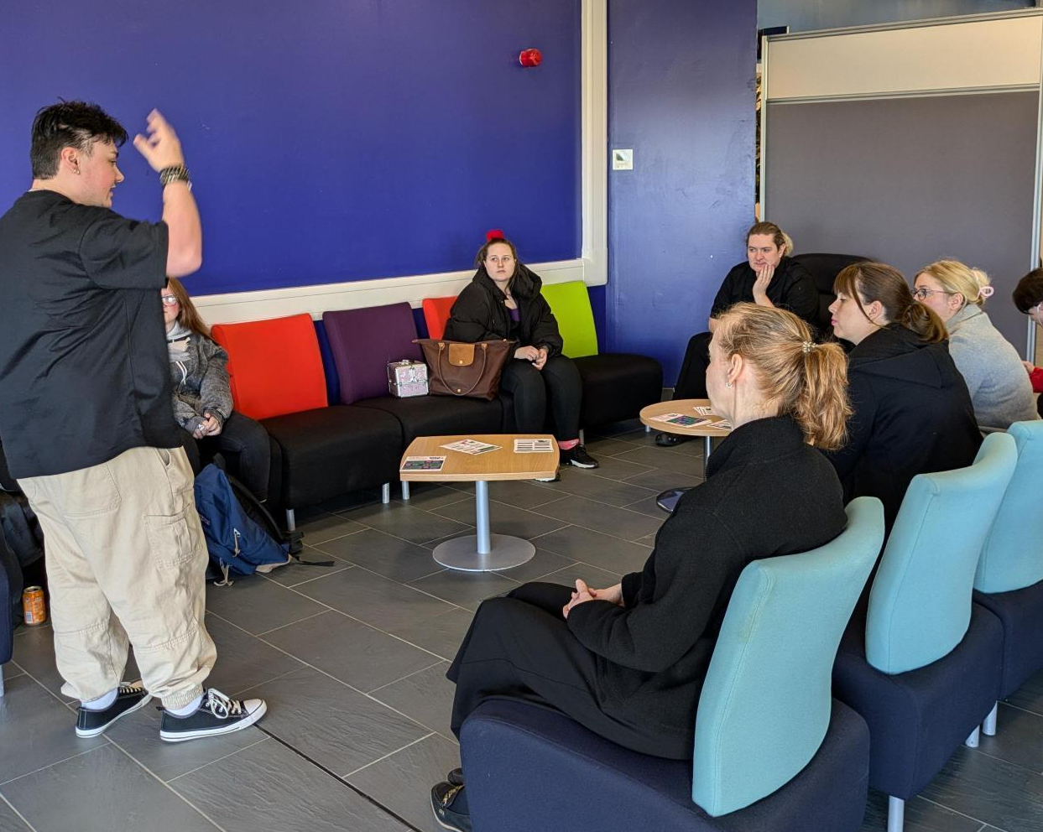
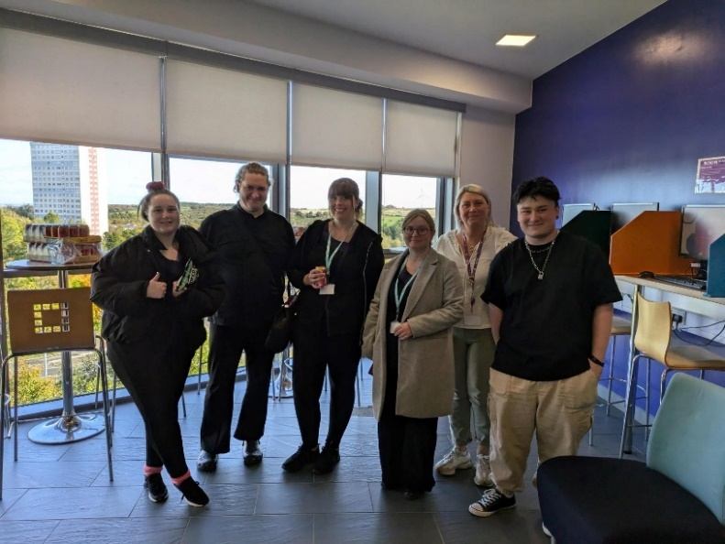

Litter Picking Event and General Activities

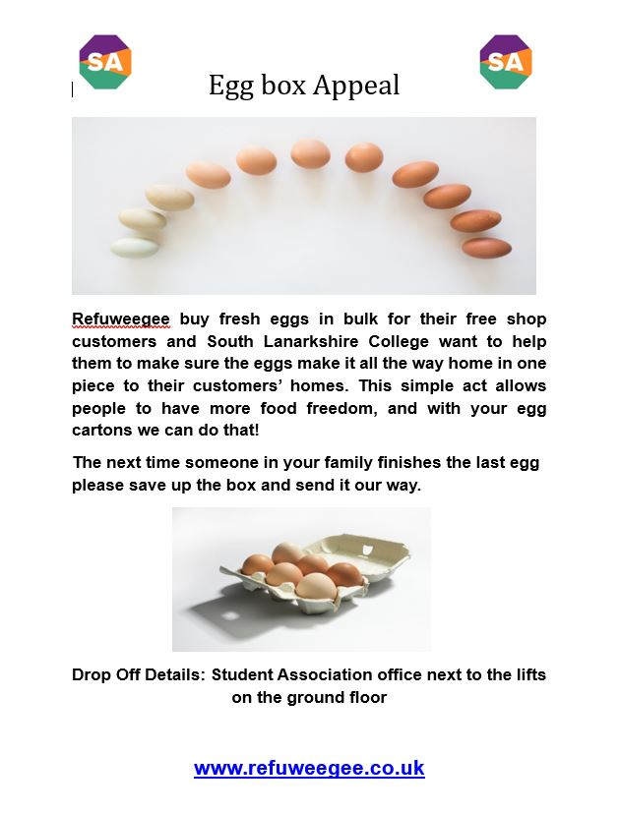
The SA organised their first litter picking day of the academic year, with plans to collaborate with Biffa for their next one in the new year. We were delighted to be supported by so many of our colleagues and students to help keep the campus clean and tidy. Communications regarding recycling and using the new vaping bins have been included in our social media channels and student newsletter.

Another activity we are keen to promote is the Egg Box Appeal run by Refuweegee. This initiative allows students to donate empty egg boxes into the SA office for Refuweegee to give to those in need. They buy fresh eggs in bulk and providing egg boxes allows them to then distribute these out.

We collaborated with our Hospitality department to arrange for a donation of some beautiful crockery to the local foodbank, Loaves and Fishes. We hope to have this delivered to them after the October week. We also helped to promote the Hospitality team’s Coffee and Cake event and went along to connect with colleagues and students.

It’s been great collaborating with different departments, and we look forward to expanding on this over the coming year.
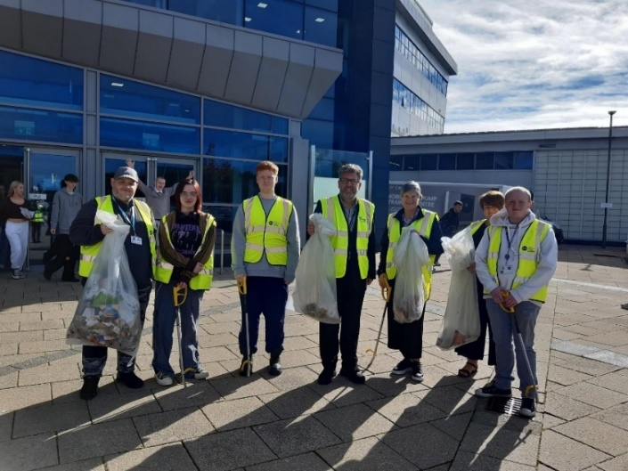
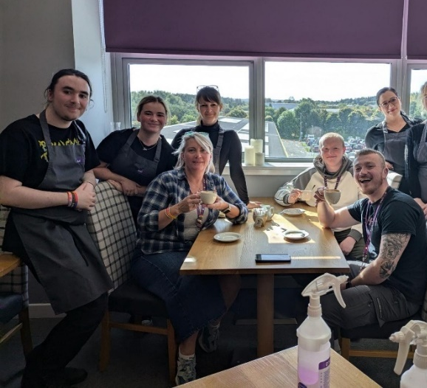

Emily Test Charter

The SA is working with the College to continue with the annual review of the EmilyTest Charter, due to take place in November 2024. We remain firmly committed to tackling GBV and providing support to our students who have experienced GBV in their lives. We work closely with the Student Services team to signpost students who require support quickly and sensitively.

The SA are also involved in ongoing promotion of the EmilyTest Charter by highlighting in the student newsletter about the award, as well as promoting EmilyTest’s request for volunteer panellists. They are particularly interested in college students being part of the panel process, so we have been keen to highlight this opportunity to our student community.

Forthcoming Events

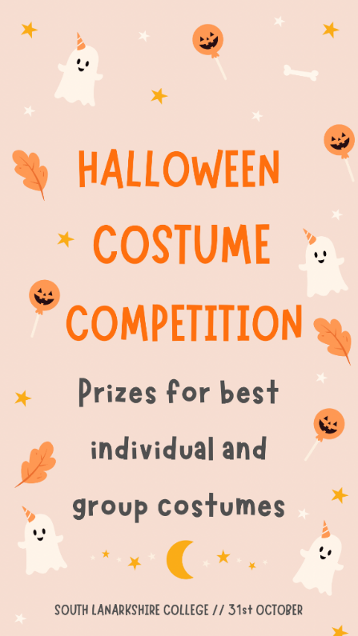
The SA have lots of activities planned for the upcoming academic year, with our next event being the Halloween Costume Competition on 31 October. We are arranging for students to take part, with the SA leading by example! Prizes will be available to students with the best solo costume and best group costume. We can’t wait to share all the brilliant photos of the event!

Below is a list of all our other upcoming events in the run up to the December 2024.

- Care Experienced Week: 19-26 October
- Halloween Costume Competition: 31 October
- Graduation: 12 November
- Movember
- 16 Days of Activism Against GBV: 25 Nov – 10 Dec

