
LEARNING, TEACHING AND THE STUDENT EXPERIENCE COMMITTEE
DATE | 3 February 2025
TITLE OF REPORT | Learning and Teaching Update including Mid-Year Review
REFERENCE | Agenda item 06
AUTHOR AND CONTACT DETAILS | Angela Pignatelli  angela.pignatelli@slc.ac.uk
PURPOSE: | To provide members with an update on credits, recruitment and retention and also update members on alternative funding and curriculum activity taking place across the college.
KEY RECOMMENDATIONS/ DECISIONS: | Members are recommended to:  - Note the credit target and recruitment to date for session 2024 to 2025;  - Note the early retention figures;  - Note the mid-year review information;  - Consider and note the work of the curriculum and alternative funding teams;  - Note the good news stories from curriculum areas.
RISK | - That the College fails to meet its credit target for session 2024 – 2025 due to recruitment challenges;  - That the quality of learning, teaching and assessment declines, negatively impacting the student experience.
RELEVANT STRATEGIC AIM: | - Successful Students  - The Highest Quality Education and Support  - Sustainable Behaviours
SUMMARY OF REPORT: | - The College credit level currently sits at 42,919 and is on track to meet the target of 43,600 credits;  - The mid-year review provides an update on benchmarked retention, Curriculum Progress Reviews with associated outputs/actions; and Operational Planning Reviews with associated outputs/actions;  - Official notification of a Modern Apprenticeship (MA) Inspection of SNIPEF activity by Education Scotland has been received and will take place week commencing 3 February 2025  - There remains significant good practice and good news stories in relation to student achievement and success already in 2024 – 2025.

- INTRODUCTION

  - This paper provides an update on the credit activity for academic year 2024-2025 and an overview of learning, teaching and alternative funding activity since the November 2024 Committee.

- CREDIT AND RECRUITMENT ACTIVITY 2023-24

  - For 2024-25 academic year, the College has a core credit allocation of 43,601 credits.

  - To date, the credit level is 41,996 credits with a projected 482 credits potential withdrawal which would be a 41,514 credit outturn which is 95% to target at this point in the year. There is a 2,087 credit gap with January starts still to pull through.

  - The table below indicates the credit level activity of actual to date against target.

Table 1: Credits to date versus target:
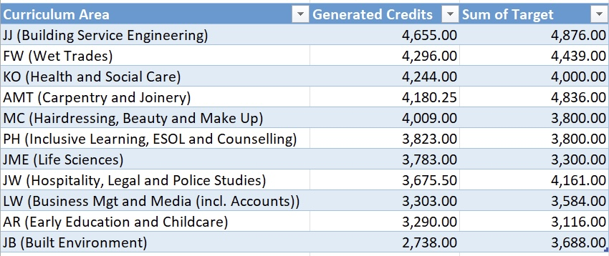

  - January start activity has yet to pull through to the system but is anticipated to be approximately 2,713 credits.

- RECRUITMENT ACTIVITY 2024-2025

  - The College overall recruitment target for year 2024 to 2025 is 5,837. The College has received a total of 4,270 enrolments and a further 952 applications for January start courses. January start recruitment indications are positive with enrolment ongoing within curriculum teams.

  - Table 2: Enrolment comparison table:

Mode | 2023 to 2024 enrolments | 2024 to 2025 enrolments | Variance
FT FE | 1,032 | 1,091 | +59
FT HE | 780 | 672 | -108
PT FE | 1,807 | 1,945 | +138
PT HE | 254 | 256 | +2
Overall | 3,873 | 3,964 | +91

  - Recruitment continues to be a top priority for the curriculum teams and the Marketing team to mitigate any potential shortfall in meeting recruitment targets in the coming months.

  - The Open Evening of 22 January took place to drive August 2025/26 recruitment. Initial indications are positive with over 120 enquires on the evening.

- CURRICULUM MID-YEAR REVIEW

  - Retention
    - The table below shows the retention and withdrawal figures to date, 22 January 2025. Intervention strategies, guidance and support are taking place across the curriculum areas to enable students to remain on their course.

    - Table 3: Enrolment, Retention, Early and Further Withdrawals February 2025

Mode | Number of enrolments | Early withdrawals | % | Number of further withdrawals | % | Retention %
FT FE | 1,091 | 36 | 3.3 | 69 | 6.3 | 90.3
FT HE | 672 | 22 | 3.3 | 45 | 6.7 | 90
PT FE | 1,945 | 52 | 2.7 | 31 | 1.6 | 96
PT HE | 256 | 12 | 4.7 | 0 | 0 | 95
Overall | 3,964 | 122 | 3.1% | 145 | 3.66% | 93%
    - A breakdown by curriculum area can be found in Annex A.

    - In a three-year comparison, the Early Withdrawal (EW) rate of 3.1% is higher than the 2% in February 2024 but an improvement on the 4.6% in February 2023. The Further Withdrawal (FW) rate of 3.66% is broadly in line with the 3.72% in February 2024 but higher than the 2.74% in February 2023. The required action planning to improve EWs and FWs is being closely monitored by Curriculum Teams and tracked at Progress Reviews. Retention rates of 93% are also broadly in line with the 93.6% February 2024 and 92.7% in February 2023.
    - The College sets the Performance Indicator (PI) targets at the start of the year and in line with the Scottish Funding Council (SFC) key categories. The college 3-year trend and the published national averages are in the below table 4 for comparison.

    - Table 4: Benchmarked KPIs:
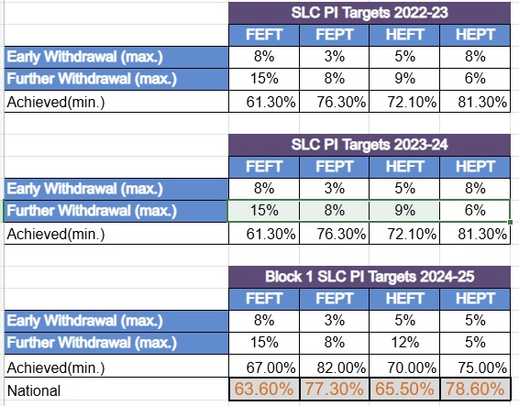

    - Across both EW and FW, the college is performing better than the benchmarked performance indicators and, in some cases, significantly better.
    - There are, however, three curriculum areas where retention falls below the recommendations above. The areas of Early Education and Childcare which is sitting at 88%; Hospitality Tourism Legal and Police Studies at 87%; and Life Sciences at 87% retention, have specific monitoring and action planning in place to address the root cause where possible.

  - Progress Reviews
    - The series of 12 Progress Reviews (PRs) across the 12 curriculum departments has concluded. This the first of the new “SLC Way” (South Lanarkshire College Way) approach to Self-Evaluation focussing on evaluative discussions around the student experience, supported by evidence, impact and action planning around what improvements are required to enable excellence in the student experience. The content of the Progress Reviews remains live throughout the year to ensure proactive interventions and ability to flex to in-year needs and issues arising.

    - Diagram 1: The SLC Way
    - The high-level findings of this series of evaluative activity has identified:
- The need for consistency in understanding and general approach to the development of MetaSkills;
- The need for consistency in understanding and general approach to the development of Core Skills;
- The prevalence of learners presenting with complex needs and learning challenges and the associated demand for Extended Learning Support (ELS);
- The prevalence of learners presenting with mental health issues;
- The need for more 1:1 guidance and tailored support for learners who, generally, are not meeting the expected SCQF level;
- The financial pressures impacting withdrawals;
- The requirement for further work on curriculum design, including enhanced industry engagement and partnerships.
    - Robust action planning has been agreed throughout the process however, a whole college approach and further discussion is vital on the above common themes if we are to enable an effective student experience and a pipeline of successful students into employment.
    - The key areas for action and enhancement include:
- Initial screening, support for learning and skills testing/development;
- Early intervention strategies;
- Core and Meta Skills development
- Staff CPD on differentiation in practice for learning, teaching and assessment;

  - Operational Planning
    - The series of 12 Curriculum Operational Planning Reviews (OPRs) across the 12 curriculum departments has concluded.
    - The aims and outputs from the Curriculum OPR process are:
- to build the next year’s Curriculum Planner (CP);
- to grow the commercial offer/full cost recovery (FCR) offer;
- to set the staffing budget, credit and income targets including Full Cost Recovery courses (FCR);
- to determine the following year’s Prospectus and curriculum offer;
- to identify short- and longer-term impacts on any other areas of the College (i.e. Facilities, IT, HR, Student Services) to inform their priorities and their Operational Plans;
- to set clear, shared actions for each curriculum area with longer term actions being included to shape the curriculum areas’ direction of travel (growth or reduction);
- to inform the Regional Outcome Agreement/SEAP and other college strategies as appropriate.
    - The high level findings of the reviews include:
    - Areas of “Growth”:
- Joinery: 3,500 timber frame specialists are required in a pipeline including a PassivHaus and Net Zero focus;
- Plastering and Roofing: SLC could be a Centre of Excellence for Plastering as currently cannot meet the demand but it is to be noted that there are physical space constraints; equally, Roofing and Bricklaying have a demand which cannot be met;
- Building Services: General growth including CECA Academy*;
- Hospitality and Tourism: over 5,000 jobs but cannot meet the demand;
- ESOL: cannot meet the demand and the College has received an urgent call to action from Community Learning Development (CLD) Network;
- British Sign Language (BSL): identified as key growth area and potential to deliver as FCR for all Front-Line Services and to align to Government Priorities;
- Health and Social Care: to align with Government priorities with focus on Care, and the potential for the College to become a Dementia Specialist College and embrace Technology Enabled Healthcare;
- CIBTAC professional registration for Beauticians is an identified area of growth in the College FCR offer.
    - Areas of Shrinkage:
- Painting and Decorating mainstream courses in order to accommodate the identified growth in roofing, joinery and plastering;
- Science mainstream courses;
- Beauty mainstream courses;
    - Over-staffing:
- Generally, class sizes are low across many courses and can be merged more creatively for theory classes and in-year across many curriculum areas;
- Early Years and Childcare: 1.1FTE overstaffing being used as absence cover;
- Built Environment: 2.2FTE overstaffing from March;
- Hairdressing, Makeup and Beauty: 3.4FTE+ overstaffing;
    - Curriculum Structure Themes Arising:
- The potential to create a curriculum area Net Zero/Green Industries cluster including subjects with a specialist focus on Net Zero, Green Skills and Sustainability;
- The potential to create a curriculum area Care Industries cluster including subjects with a specialist focus on Health, Care, Social Care, Wellbeing, Inclusive Learning, Counselling;
- The potential to create a Learning and Teaching Academy including oversight of pedagogical advances, sharing practices, enhancement activity and formal training including for TQFE, TiCT and PDA LTA;
- The potential for de-grouping of some existing curriculum areas to align to the above.
    - Student Experience Themes Arising:
- Supporting Students: there is significant evidence of the strain on lecturing and support staff given the variety, volume and complexities of student issues, referrals, counselling, neurodivergence and learning styles;
- Schools Liaison Key Contact: there is no ownership or key contact linking with schools to enable a secure pipeline of schools;
- Timetabling System: one is urgently required;
- Learning Technologist(s): is urgently required;
- Centralised IT Hub: is urgently required and laptop loans for students;
- External teaching spaces required: areas such as Early Years and Childcare, Wet Trades, Building Services Engineering require external teaching spaces;
- Learning Hub location: generally receiving negative feedback and needing rethought.
    - Cross College thematics of Best Practice to be shared peer-to-peer/CPD days:
- Meta Skills, Essential Skills, Core Skills PLP and BKSB: Early Years &Childcare staff, Health and Social Care staff, Life Sciences staff;
- Blended Learning techniques: Jamie Beddows, Jennifer McEwan, Margaret Campbell, Katie Orchiston;
    - Cross College CPD required:
- Blended Learning;
- Digital upskilling from basic use of MS Teams to Advanced AI;
- Trauma Informed Practice;
- Toolkit for SCQF level3/4 cognitive abilities of students;
- Student Basic digital literacy.

  - The Operational Planning Reviews for Support Teams starts week commencing 3 February 2025, the findings of the curriculum OPRs will inform their planning prioritisation.
4.5 Modern Apprenticeships
4.5.1 The Apprenticeship provision at the College remains strong with 839 apprentices enrolled at the College with 80 still to enrol. Currently 263 apprentices are in training through our contract with Skills Development Scotland (SDS) and in addition to our contract with CITB and SNIPEF.
4.5.2 There is a target of 110 starts on the current contract:
- 58 new starts to date plus 6 re-entrants with 52 new starts remaining;
- The contract value is £627,307 with a target spend of £595,941. £428,433 has been spent to date with £167,508 remaining. There is a projected spend to be re-forecasted due to the knock-on effect of slow recruitment;
- This is a reflection of lower staff recruitment in industry, especially in the construction sector.

4.5.3 the planned/confirmed Intake for January-March is as follows:
- 15 x SVQ 3 – Social Services & Healthcare with NHS;
- 1 x SVQ 3 – Healthcare Support with NHS;
- 8 x SVQ L9/10 Care Services Leadership and Management;
- 4 x Hairdressers;
- 4 x Hairdressers progressing from L2 to L3;
- 4 x Carpentry & Joinery site starts;
4.5.4The continued close working relationship with the NHS has resulted in the allocation of 15 spaces for Business and Administration in the College contract. Confirmation from the NHS will be soon.
4.6 CECA ACADEMY
4.6.1 The College is delighted to announce the progression of a partnership with CECA (Civil Engineering Contractors Association) to provide the new SLC CECA Academy. Supported by MacKenzie Construction and George Leslie, the facility and venture will enable a realistic training and working environment for our students.
    - The Academy will:
- Shape Scotland's Future: to work in roads, rail, water, and power sectors;
- Consist of an18-Week Programme: to gain hands-on, immersive training at the college;
- Focus on Outdoor Learning: to build practical skills in health, safety, and groundworks;
- Provide career-focused training: to develop job-ready skills and experience;
- Ensure a guaranteed interview: completion of the course secures an interview with a local construction company.
4.6.3 The first intake started 20 January 2025 with formal launch planned for February 2025.

- EDUCATION SCOTLAND
  - The College has received formal notification of an upcoming review which Managing Agent, SNIPEF (Scottish and Northern Ireland Plumbing Employers' Federation) have with His Majesty’s Inspectorate (HMIe) to review the Modern Apprenticeship (MA) training in Scotland. The Inspectorate will meet the College staff and conduct a review on Thursday 6 February 2025 covering the following key areas:
- professional dialogue with provider managers and staff;
- professional dialogue with employers and apprentices;
- arrangements for quality assurance and evaluation;
- identification of core and meta skills;
- safeguarding and supporting students; and
- sharing best practice.

5.2 Verbal feedback will be provided at the end of the day focussing on the themes of Leadership and Quality Culture; Service Delivery; and Safeguarding and meeting the needs of apprentices. Reports will take 6 weeks and will be shared with the Scottish Government and Skills Development Scotland (SDS).
- ALTERNATIVE FUNDING UPDATE

  - CLIC (College Local Innovation Centres) Project update

    - South Lanarkshire College is home for the Innovation Centre for Sustainable Development and is engaging with local business support networks including South Lanarkshire Council Business Support team, Business Gateway, Hub Southwest, CEED and other key stakeholders in the innovation ecosystem. Funding is in place until 31 March 2025 and the College stands to recognise £191k of funding through its delivery of the programme (£197K initially approved, £6k worth of sub-contracts (web portal design and project evaluation) will now be invoiced and claimed by City of Glasgow College on behalf of each of the consortium partners for easier auditable trails). The panel were cheered at the volume of interest and the calibre of candidates. Succession planning and further development & training opportunities will be noted and explored to harness staff enthusiasm and ambition.
    - Each College within the Glasgow City Region is working with approximately 35 businesses across the length of the project and this interaction will involve an early discussion of business needs in relation to each College’s specialist area, signposting them to a potential workforce programme on the following core topics (not exclusive):
    - Digital Marketing (21-11-24)
    - AI (21-11-24)
    - Heat Pump Training (Dec-Jan)
    - ILM – Sustainability Development Unit (tbc)
    - AI and Power BI (Digital footprint) (tbc)
    - Solar Power and Batteries (tbc)
    - CLIC Managers involved in the project ensure that sufficiently skilled staff are involved to support in the delivery of these programmes and explore ways to involve new staff with relevant expertise. It is hoped that the rollout of initial workforce programmes by staff may encourage local businesses to engage with our college on a number of initiatives and explore further training opportunities on a commercial basis.
    - Future events are being planned, approximately monthly, covering topics such as AI and Digital Marketing, Sustainability of the Built Environment, Sustainability Credentials and Meet the Employer Collaboration. All to be hosted at SLC, showcasing the skills and capabilities of our catering and events Teams whilst providing networking opportunity within the CLIC community at the same time as delivering part of the business needs and support required by those businesses who have completed the innovation assessment.
    - The January event in construction procurement is designed to meet a commonly expressed issue regarding the difficulty SME contractors and suppliers have in meeting increasingly onerous sustainability and quality criteria in order to be considered for tender lists. We now have a wide network of businesses ranging from large construction companies to smaller contractors and suppliers who are looking to work together to improve their sustainability. These interventions can be registered through the evaluation tool and the data recorded by the CLIC project.

  - The Employability Academy:
    - The Employability Academy (Previously The Rural Academy) is funded through South Lanarkshire Council with No-One Left Behind funding (1st October 2024 to 30th September 2025) with a total contract value: £210,000.
    - To date, the courses confirmed include:
- Introduction to Cookery 6 weeks x 5 hrs per week being delivered in St. Nicholas Church Hall, Lanark start date 24/01/2025;
- Social Media & Mental Health 2 weeks x 3 hours per week – Online Delivery start date 05/02/2025.
6.2.3 The courses being discussed for planned delivery after the Easter Break are as folows:
- Intro to Classroom Assistant 4 weeks x 15 hours per week;
- Paediatric First Aid (accredited) & First Aid (non-accredited) 2 weeks x 12 hours per week;
- Pre-NHS Course – Pathway courses with specific requests for Infection Control, Safeguarding, HIV awareness, Human Anatomy;
- Basic Computer Skills, Admin/Clerical Skills, Customer Care, Effective Communication;
- Catering & Cleaning Course.
6.2.4 South Lanarkshire Council are looking to fill vacancies throughout SLC and require a course to cover both Catering and Cleaning as indicated above to include:
- REHIS, Allergen Awareness, Hygiene Awareness;
- COSHH, Health & Safety, Moving & Handling;
- Personal Assistant;
Some training which could cover care of an individual who requires a personal assistant to help with everyday living giving assistance with Shopping, Personal Care, Befriending, Travel buddy, Household duties.
- Supporting Families;
- Introduction to Barista, REHIS.
    - Further discussions are taking place to deliver:
- ESOL – there is a South Lanarkshire wide shortage of delivery of ESOL;
- BSL – Information is being collated to send to the LEP to raise awareness.

  - Commercial Activity/ Full Cost Recovery (FCR)

    - Monthly meetings of the Full Cost Recovery Team continue to take place to monitor the progress to target for this diversification Activity. Full Cost Recovery income is currently £93,220 against a target of £125,000 to July 2025 = 75% to target, with delivery across curriculum areas.
    - British Sign Language and Dementia Awareness courses have been identified as growth commercial areas. Courses are planned to generate Full Cost Recovery income
    - Contact with businesses will be made through our CRM to promote the courses to front-line staff (NHS, Police, Emergency responders, Care Homes etc.)
    - The CLIC (College Local Innovation Centres) project, funded through Innovate UK Further Education Innovation Fund, has been a significant vehicle to promote college courses and services. The business engagement element of the project has opened opportunities for commercial opportunities on the back of initial support from the CLIC team
    - The College Partnership with MacCrae Training is being formalised with rental income forecast for space to the rear of the campus.

- EQUALITIES
There are no implications for people with protected characteristics or from areas of multiple deprivation which arise from consideration of the report. The College will continue to work to ensure equal opportunities for all in our students’ experiences at the college.

- RISK AND ASSURANCE

- That the College fails to meet its credit target for session 2024 – 2025 due to recruitment challenges;
- That the quality of learning, teaching and assessment declines, negatively impacting the student experience.

- RECOMMENDATIONS
Members are recommended to:
- Note the credit target and recruitment to date for session 2024 to 2025;
- Note the mid-year review information;
- Consider and note the work of the curriculum and alternative funding teams;
- Note the good news stories from curriculum areas.
ANNEX 1

Table 1: Overall Curriculum Area Enrolments, Retention, Early and Further Withdrawals 22 January 2025

Mode | No. of Enrolments | Early Withdrawals | % | No. of Further Withdrawals | % | Retention %
Building Service Engineering | 376 | 4 | 1.06 | 5 | 1.33 | 97.6
Built Environment | 313 | 9 | 2.9 | 7 | 2.24 | 95
Business Management and Media and Accounts | 528 | 18 | 3.4 | 22 | 4.2 | 92
Carpentry and Joinery | 361 | 1 | 0.28 | 0 | 0 | 99.7
Early Education and Childcare | 303 | 15 | 4.9 | 20 | 6.6 | 88
Hairdressing, Beauty and Make Up Artistry | 431 | 16 | 3.7 | 19 | 4 | 92
Health and Social Care | 344 | 13 | 3.8 | 17 | 4.9 | 91
Hospitality, Tourism, Legal and Police Studies | 335 | 18 | 5.3 | 25 | 7.4 | 87
Inclusive Learning | 360 | 14 | 3.9 | 12 | 3.3 | 93
Life Sciences | 256 | 11 | 4.3 | 22 | 8.6 | 87
Wet Trades | 354 | 3 | 0.85 | 1 | 0.3 | 99

Curriculum Good News Stories

Good News Stories

Representatives from Business Gateway delivered an information workshop session covering self-employment to a range of student groups across Hairdressing, Barbering and Beauty Therapy on Wednesday 12 November 2024. The session provided a comprehensive overview of Business Gateway services available to those students seeking to explore self-employment as a career progression pathway on completion of their studies at college.

As part of this session a dedicated section covering business advice for small and medium enterprises (SMEs) and business start-up planning was included which covered the basics around key self-employment, business start-up and freelance working considerations.

Finally at the end of the workshop there was a Q&A segment which allowed students to ask additional questions around the above topics. Students were also able to register online with Business Gateway which then entitled all participants to a follow up “1 to 1” call with an adviser within 3 working days. All students fed back positively saying that they found the session highly beneficial and informative. In addition, many found the timing of delivery especially helpful at such a crucial time in their studies, enabling them to make more informed choices regarding their future career. Business Gateway also agreed to share digital information to be disseminated more widely across the student community.
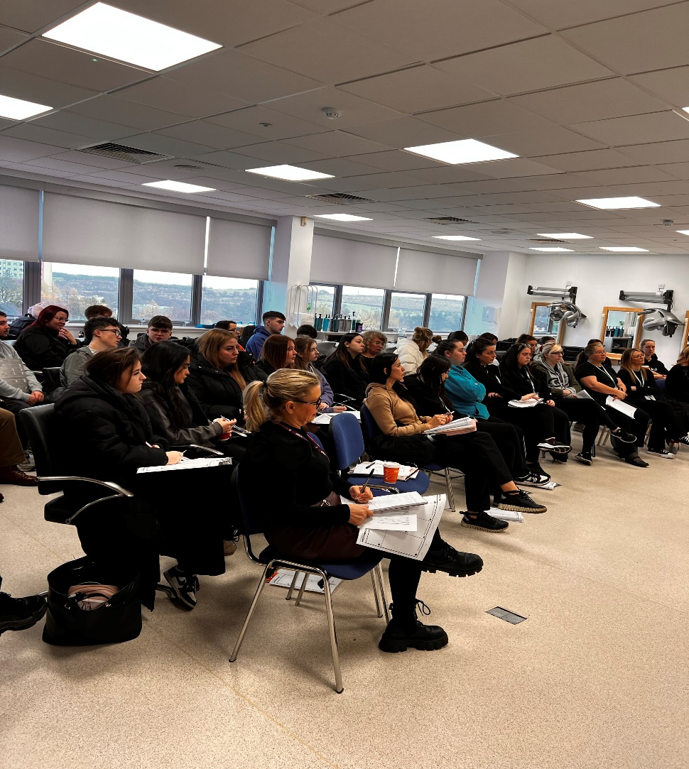
Minister’s visit 22 October 2024

Mr Neil Gray MSP, Cabinet Secretary for Health and Social Care visited the College on the 22 October 2024 and met with groups of HNC Healthcare Practice students. A range of key sector issues were discussed during the session including the high importance Government placed on the provision of quality health and social care and allied health education. The Minister was eager to learn about our ongoing efforts in health and social care, and he was given a tour of our Healthcare Practice and Scottish Widening Access (SWAP) Nursing student facilities.
During his visit Mr Gray actively participated in a blood pressure check, listened to an engaging self-care blog presentation from one of our SWAP Nursing students. He also participated in resuscitation techniques to the tune of the Proclaimers “500 Miles” a learning and teaching approached used to promote the importance of establishing a rhythm when administering and developing compressions techniques.
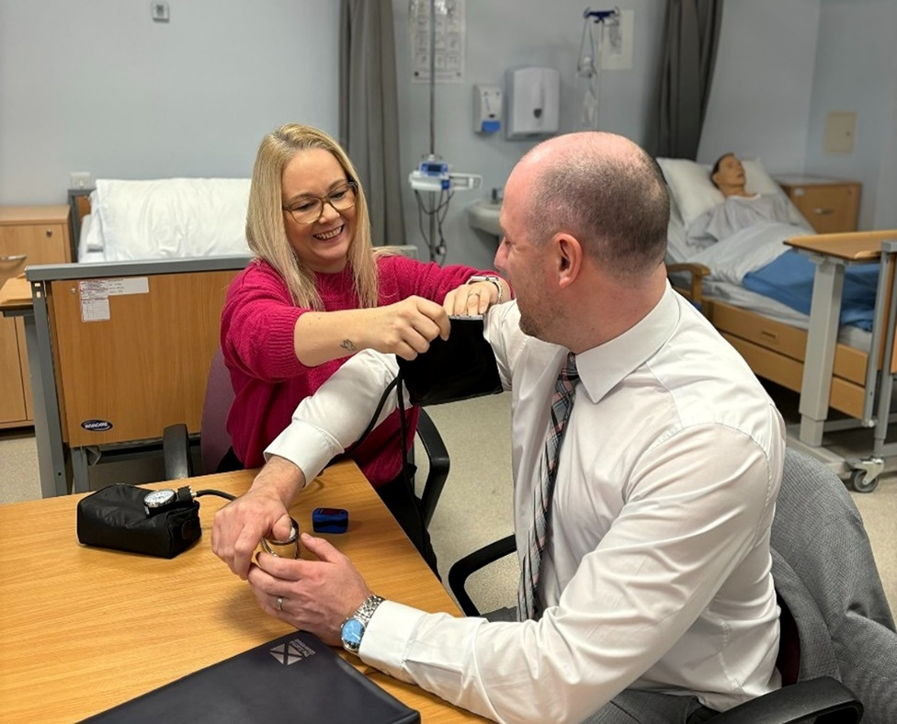
The Cabinet Secretary took time to speak with the students and discuss the future of health and social care in Scotland and Mr Gray emphasised the important role that Health and Social Care Practitioners play and explained that he was delighted to be able to speak to them in person to express his personal and professional gratitude for the work that they are doing.

BE-ST Award
The College won Collaborative Partnership Award with the Energy Savings Trust as part of the Construction BE-ST – Accelerate to Zero Awards. This was announced on Thursday 7 November.
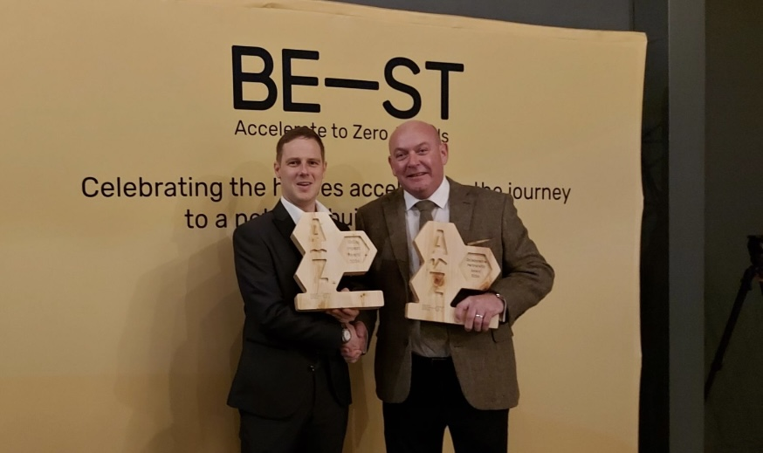

SLC Best decorative and fibrous plastering training provider in the country.
Staff members - Lewis Anderson and Jamie Acheson collecting the award December 2024.


CECA Academy

