
South Lanarkshire College

Students’ Association

Board Report

August 2024



Contents
Overview 3
Emily Test Gender-Based Violence (GBV) Charter 4
Student Poverty/Cost of Living 4
Student Mental Health Agreement 4
2024-25 Operational Plan 5
NUS Lead & Change 6
Pride Event 7
Forthcoming Events 7

Overview

SA Plans for The New Curriculum Year

Over the summer the Student Association have been busy with completing our draft Operational Plan, Social Media plan and reviewing our Strategic Plan for the upcoming year. We are on track to have all the above completed ahead of schedule so we can spend time welcoming the students in for the new academic year. We have also completed a PowerPoint for the class talks and completed an introduction video for our social media welcome.

The SA are thrilled to welcome the students back for a busy but fun academic year, we have been making plans for Freshers’ Week and have arranged lots of fun activities, with plenty of freebies being arranged for competitions and the SA stall. This year we will be hosting events and regular activities to keep the students engaged with the SA throughout the year. We are committed to supporting our students and plan to ensure they are continuously aware of all SA activities happening on campus, ranging from mindfulness to student poverty initiatives – we are here to help!

The SA President and Vice President will carry out class visits to help spread the word on our plans for the year. We will collaborate with all curriculum departments to create more involvement for the class reps and promote the SA Officer elections later in the year.

Student Poverty/ Cost of Living

With the ongoing cost of living crisis, we are committed to supporting our students and tackling student poverty. We will work in partnership with the College’s new catering partner Aramark to continue to support the students with free soup and sandwiches and breakfast on designated days, alongside the continued availability of the Student Larder for food and personal items located in the SA office. We are also keen to keep working with the Learning Development team to keep students warm by providing free clothing for all ages via the College Way Market. This is planned to be replenished with sessional items throughout the year and is located on the ground floor.

The SA President and Vice President are committed to helping students make connections with each other and we are hoping to do this by introducing Connect 4 tournaments to help students make new friends.

Emily Test Gender-Based Violence (GBV) Charter

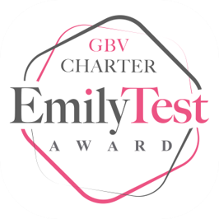
We are incredibly proud that the College was the first college in Scotland to receive the EmilyTest GBV Charter Award in November 2023. The SA are committed to continuing with this very important work and working in partnership with the College to continue to tackle GBV. The next submission of the Charter will take place in November of this year, and we look forward to being involved in working towards this.

Student Poverty/Cost of Living

The ongoing cost-of-living crisis continues to have a major impact on our students, and we are committed to continuing to support them through this difficult time. As part of our initiatives for this upcoming year, we will work with Aramark to continue to provide free soup and a sandwich to students one day per week, as well as free breakfast one day per week. We have already meet with the new catering supplier to discuss this and we are keen to see if there is anything different we can provide students in the upcoming academic year.

Once again, we would like to sincerely thank the SLC Arm’s Length Fund for their support in being able to provide this to our students for academic year 2024/25. In academic year 2023/24, in partnership with Inspire at the time, we provided an amazing 13,000 servings of both soup and sandwich and breakfast to our students. Student testimonials to this offering have been overwhelmingly positive and we look forward to being able to continue to provide it.

Alongside this we will continue to operate the Student Larder where students can visit the SA office and collect much needed food and toiletries. We will also be providing students with free pens, notebooks and blank folders to ensure they have essential stationary products. Throughout the year we will work closely with our colleagues in Student Services to signpost students to discretionary funding, as well as promote financial support through the SA fortnightly newsletter.

Student Mental Health Agreement

We were delighted to launch our Student Mental Health Agreement (SMHA) in 2022-2024 and are committed to continuing with creating a new SMHA to cover the next two academic years. The SA will work in partnership with Student Services and the wider college community to identify areas of priority. We look forward to hearing from students as to what they think would benefit them in the SMHA going forward.

2024-25 Operational Plan

The SA has completed the 2024/25 Operational Plan and Social Media Plan. We are currently in the process of finalising our Strategic Plan.

Our focus for the upcoming year is the following three priorities:

- empowering the student voice
- Making sure all our students feel welcome and included
- organising games and activities to make sure our students have fun

We have prepared a SA Induction PowerPoint and we will send out emails to all departments to book class visits. We want to be as visible as possible and have created an induction video for our social media accounts. This will help us to make sure all students know who we are and the support we offer. In addition to this we’ll be welcoming students in the Atrium as they arrive on campus for their first day of class.

We want to bring the fun back for our students, so we have planned fun activities and games for Freshers’ Week, due to take place from 9-11 September. We will also be selling hoodies for the current academic year during this week.

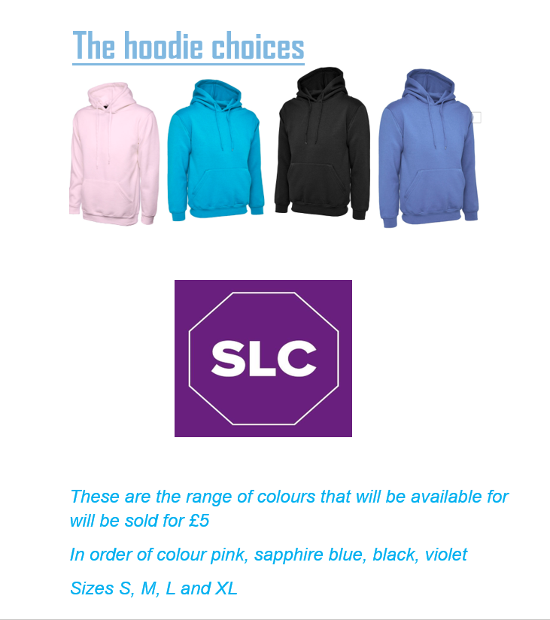
The SA President and Vice President believe that the SLCSA embroidered hoodies will help to keep students warm and they will remain accessible to all students as we are maintaining the very low price of £5 per hoodie. This is important to help our commitment in trying to tackle the large issue of student poverty.

NUS Lead & Change


The SA President and Vice President have been busy over the summer. We attended Lead and Change, an exciting and informative event hosted by NUS. Attending this allowed us to network with other officers either in their first or second year. As this was a new opportunity for us all the information was invaluable.

The second-year officers were very open about their experiences which gave us more confidence to embrace our new position with a better understanding of what we are here to achieve, which is helping students to have the best college experience they can have. We look forward to supporting students on their chosen career path and supporting them with access to food, clothing and guidance.

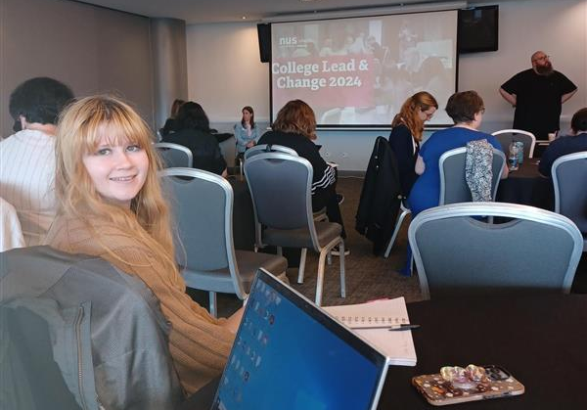
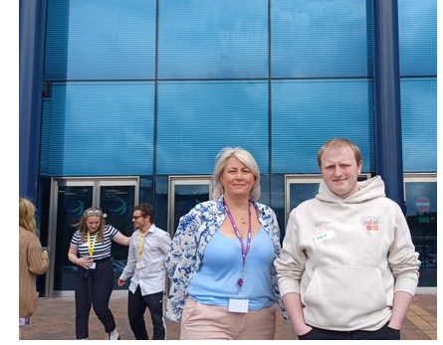
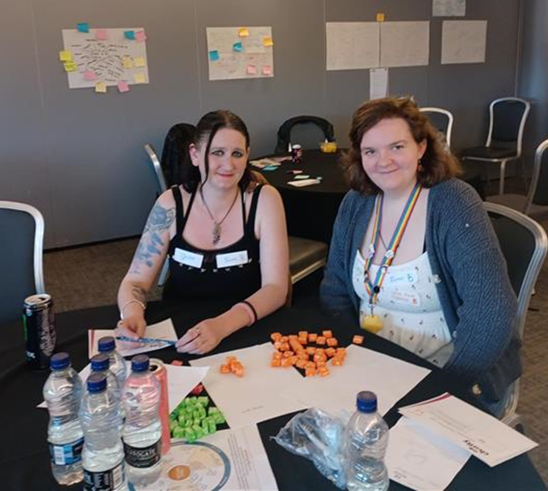

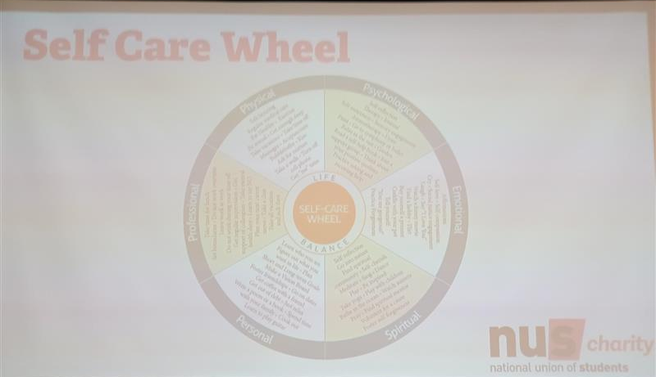

Pride Event

The annual Pride event took place in Glasgow this summer and SLC and SA staff were in full attendance. We had a wonderful time at the event showing our support for the LGBT+ community, we even had two of our pictures highlighted in the local newspaper!

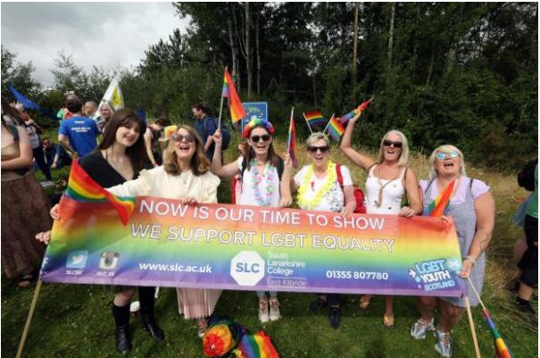

Forthcoming Events

Welcoming the students
Monday 26 August

Freshers’ Week
Monday 9 – Wednesday 11 September

Volunteering Event
30 October

Halloween
Halloween costume contest 31 October

HE Event
14 November 24

Men's Mental Health Month/Movember
Throughout November (Cuppa and a Chat event)

GBV 16 Days of Activism
25-November – 10 December

Sexual Awareness Stall
13 December (Cuppa and a chat, free condoms, etc)

Refreshers’
28-30 January

Love Your Planet
14 February

LGBT History Month and Purple Friday
Throughout February and 28 February

Easter
Easter egg hunt Friday 18 April

We are very much looking forward to the events listed above and have lots of great ideas for the year ahead including activities over lunch, such as games, Connect 4 tournaments, sudoku, crafts and much more!

