

South Lanarkshire College

Students’ Association

Board Report

August 2023



Contents
Overview 3
Student Engagement 3
Emily Test Gender-Based Violence (GBV) Charter 4
Student Poverty/Cost of Living 4
Student Mental Health Agreement 5
2023-24 Operational Plan 5
College Hoodies 6
Lead and Change 6
Events 7
Staff Conference 7
Forthcoming Events 7
Freshers’ 7

Overview

Student Engagement

Throughout summer, the Student Association has completed a draft Operational Plan, Social Media Plan and are finalising our Strategic Plan. We are aiming to complete all these key documents prior to students returning so that we can turn our focus to welcoming them onto campus. We have also completed a welcome PowerPoint to introduce ourselves during class visits.

The Student Association Office has had a refresh over the summer months. We had the walls painted, replaced the carpet and requested a full deep clean of the space. The furniture has been moved around to create a more welcoming and inviting space for students to visit. We have also had the cabinets moved away from the window to make the office more visible to students.

The Student President and Vice President have been working with Guidance and Support Advisor Maggie Farrell to produce an Anxiety Webinar. This webinar will provide an overview for students on how to manage anxiety, featuring different tips and techniques that they can put into practice. We have recorded over a PowerPoint that will be shown to students when they come back from their summer break.

The Food Larder has been refilled so that we can immediately help students who are struggling for food. Students have already been made aware of this via promotion on social media for when they return. We will also shortly be confirming dates with Inspire for free soup and sandwich/breakfast starting in September. We have arranged a supply of free stationary for our students to pick up including notepads, pens and folders. Alongside this we have worked with Student Services to order in more free sanitary products for students and will be creating holiday packs for students to collect prior to the September Weekend and October break.

The SA have been very busy planning Freshers, which will take place from 11 to 13 September. We have reached out to different organisations and companies to invite them to our Freshers Event. Many companies have confirmed that they are coming, and spaces are filling up quickly.

The SA is very excited to welcome students back after the summer break. We will be working hard to raise awareness of the Student Association with students and promoting the services that are available to them. This will include hosting more activities and events on campus, visiting classes, working in partnership with Curriculum Areas and Departments, and being more involved in the Class Reps process.

As this report will highlight, 2022-23 was a busy year for the SA and we look forward to building on this for the upcoming academic year.

Emily Test Gender-Based Violence (GBV) Charter


Our full EmilyTest submission took place earlier this year and we are eagerly awaiting the final response to this. We are confident of a positive outcome for our Charter submission due to the huge amount of work that has taken place over the last year.

The SA has been directly involved in much of the activity, including co-ordinating gender-based violence prevention workshops with students to help raise awareness of our zero-tolerance approach to GBV, as well as gaining valuable insight from students on the work being undertaken. This important work will continue into the new academic year with the introduction of a new e-learning module for students about GBV, created by Lanarkshire Rape Crisis, in addition to continued promotion of the support available. We will also be re-launching our Report and Support software to all new and returning students so that they are aware of how to raise any concerns to staff.

Student Poverty/Cost of Living

The ongoing cost-of-living crisis continues to have a major impact on our students, and we are committed to continuing to support them through this difficult time. As part of our initiatives for this upcoming year, we will continue to provide free soup and a sandwich to students one day per week. We would like to take this time to sincerely thank the SLC Foundation for their support in being able to provide this to our students. This support means we can continue to provide a healthy breakfast and lunch to those most impacted by rising food costs, which in turn will help them to focus on their studies. In 2022/23, in partnership with Inspire, we provided an amazing 17,186 servings of both soup and sandwich and breakfast to our students. Student testimonials to this offering have been overwhelmingly positive and we look forward to being able to continue to provide it.

Alongside this we will continue to operate the Student Larder where students can visit the SA office and collect much needed food and toiletries. We will also be providing students with free pens, notebooks and blank folders to ensure they have essential stationary products. Throughout the year we will work closely with our colleagues in Student Services to signpost students to discretionary funding, as well as promote financial support through the SA fortnightly newsletter.

Student Mental Health Agreement

We were delighted to launch our Student Mental Health Agreement for 2022-2024 last year and look forward to continuing to deliver the initiatives from it over the upcoming year. The working areas for the SMHA were as follows:

- Continuing to Address Student Poverty
- Peer Support through Games & Activities
- Supporting Men’s Mental Health

We have already achieved a great deal in addressing these areas but look forward to building the great work already done. To find out more about our SMHA, please visit the Student Associations’ webpage here: https://www.slc.ac.uk/students/student-association/

2023-24 Operational Plan

The SA has completed the 2023/24 Operational Plan and Social Media Plan, plus we are finalising our Strategic Plan.

Our focus for the upcoming year is the following three priorities:

- empowering the student voice;
- Making sure all of our students feel welcome and included;
- organising games and activities to make sure our students have fun.

We have prepared a SA Induction PowerPoint and we will send out emails to all departments to book class visits. We want to be as visible as possible and have created an induction video for our social media accounts. This will help us to make sure all students know who we are and the support we offer.

We want to create lots of fun activities for our students to get involved in throughout the year and look forward to engaging with students.

College Hoodies

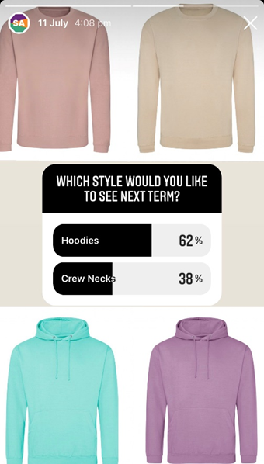
The Students Association have sent out emails to request three quotes for hoodies. This is still to be approved but we are hoping to order 355 hoodies for our students. We believe it is important to provide these fantastic products to our students and to maintain the low price of only £5 per hoodie. This initiative is important as part of our commitment to tackling student poverty and providing a high-quality garment at a subsidised costs to students.

We have decided to continue with the same design of hoodies that was decided by students last year, however we will be putting out a new poll via social media for students to decide on the colours they would like to see. We believe that our students deserve to choose what they will be buying.

We are empowering the student voice by making sure they are included in decisions such as these. We will post on our social media a poll & post where students can vote and have their voice heard, thereby helping build their confidence, trust, and a relationship with the SA.

Lead and Change


During the summer holidays we attended Lead and Change, an exciting and informative event. We learned about self-care, and helpful tips for starting this new opportunity within the SA.

We were able to discuss what to expect from the second-year officers. We learned more about adopting a balanced lifestyle focusing on mental, physical, and sociological wellbeing. This is key to our roles because if we take good care of ourselves, it will enable us to take greater care of our students. This will also help us maintain our passion by always reflecting and remembering our values and what we stand for.

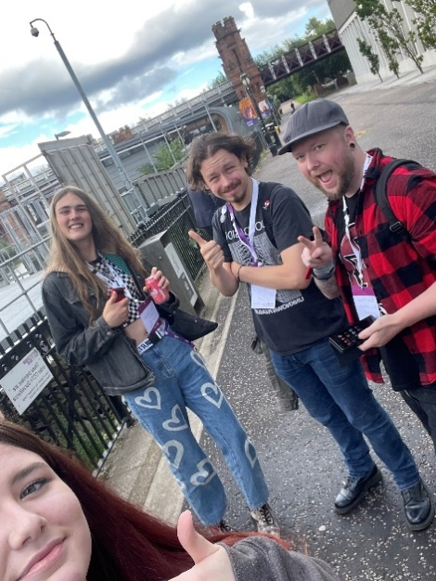
We have also learned about barriers, as well as the importance of saying ‘NO’ without feeling guilty for it because it is about self-love/care. We discussed and learned about our values, i.e. what we stand for, goals in life and aspirations.

We learned about the struggles students are facing during this cost-of-living crisis. We were given space and encouragement to create ideas on how best to support our students.

We had the opportunity to meet SA representatives from across all of Scotland and it was great to see what other institutions are doing. We were able to share ideas and we found out that SLC is doing great at supporting the SA! This has resulted in us having much more appreciation for the support we have from the College!

Overall, we learned a great deal and enjoyed our time. We made friends and gained a wider perspective on what it means to be a great, caring, successful leader.

Events

Staff Conference

Tuesday 15 August

The SA were delighted to be invited to the College’s All Staff Conference on 15 August. It was great to hear from different speakers, including Principal, Stella McManus, on what the College’s plans and goals were for the upcoming academic year. It was also a great opportunity to meet staff from across the College and talk with them about how the SA can work with different areas to support our students. Overall, it was great to be involved in such an engaging event!

Forthcoming Events

Freshers’

Monday 11 – Wednesday 13 September

Freshers’ Week is scheduled to start on Monday 11 September and we’re looking forward to engaging with students! We will be hosting a SA stall where we can promote the different initiatives the SA are involved in, as well as signpost to all the fantastic support services available within the College.

As with previous years, we have invited various stall holders for the College Atrium to give students the opportunity to learn more about what’s available in their local area. Organisations confirmed to be attending include Police Scotland, Covey, Samaritans, Carers Trust Scotland, Dominos, Women’s Aid, Money Matters and many more.

In addition to all these fantastic organisations being available, we are also arranging wellbeing sessions and the always popular Prize Pong! The Library will be set up as a Wellbeing Zone where students can talk with organisations such as NHS Inform, Breathing Space, JD Gyms, LAMH and more. There will also being mindfulness classes, arm/hand massages provided by LUSH and manicures provided by SLC students. Throughout the week we will also be selling the SLC hoodies to students. We will be taking photos and promoting on social media throughout the day so ensure as many students as possible can take part in the event.

