
LEARNING, TEACHING AND THE STUDENT EXPERIENCE COMMITTEE
DATE | 4 November 2024
TITLE OF REPORT | Learning and Teaching Update
REFERENCE | Agenda item 06
AUTHOR AND CONTACT DETAILS | Angela Pignatelli  angela.pignatelli@slc.ac.uk
PURPOSE: | To provide members with an update on credits, recruitment and retention and also update members on alternative funding and curriculum activity taking place across the college.
KEY RECOMMENDATIONS/ DECISIONS: | Members are recommended to:  - Note the College has completed the FES return and the credit audit and met the core credit target for 2023 to 2024.  - Note the credit target and activity to date for session 2024 to 2025;  - Note the recruitment figures update for academic session 2024 – 2025;  - Note the early retention figures;  - Note the STEM activity which has taken place;  - Consider and note the work of the curriculum and alternative funding teams;  - Note the good news stories from curriculum areas.
RISK | - That the College fails to meet its credit target for session 2024 – 2025 due to recruitment challenges;  - That the quality of learning, teaching and assessment declines, negatively impacting the student experience.
RELEVANT STRATEGIC AIM: | - Successful Students  - The Highest Quality Education and Support  - Sustainable Behaviours
SUMMARY OF REPORT: | - The College has completed the FES return and the credit  audit and met the core credit target for 2022-23;  - There are challenges around recruitment in some areas,  but further in-year activity is still to take place;  - Student early retention figures remain high at this point in the year;  - There remains significant good practice and good news stories in relation to student achievement and success already in 2024 – 2025.

- INTRODUCTION

  - This paper provides an update on the credit activity for academic year 2024-2025 and an overview of learning, teaching and alternative funding activity since the August 2024 Committee.

- CREDIT AND RECRUITMENT ACTIVITY 2023-24

  - The College has completed the FES return on 9 October 2024, and the credit audit, and met the core credit target for 2023 to 2024.

  - For 2024-25 academic year, the College has a core credit allocation of 43,601 credits.

  - To date the credit level is 37,214 which is 85% to target. There are 3,800 credits planned for January course recruitment resulting in an identified 2,386 credit gap. The curriculum areas are working on action planning to address this shortfall.

  - The table below indicates the recruitment and credit level activity of actual to date against target.

  - Table 1: Credits to date versus target:

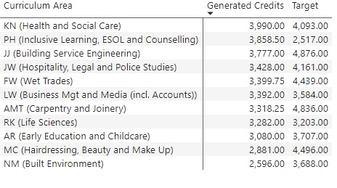
*please note 1,141 credits are yet to pull through for Hairdressing, Makeup and Beauty

  - Some curriculum activity is yet to pull through on the system, however, recruitment has
been slightly lower than expected in the areas of Early Education and Childcare and Health and Social Care. This has negatively impacted on the credit target by just under 1,000 credits. Recruitment has been, as predicted, lower in the area of Construction, with several apprenticeship programmes effected. This has negatively impacted on the credits by approximately 1,400. Curriculum managers are working on alternative offerings as part of the January recruitment process to support the current shortfall.

- RECRUITMENT ACTIVITY 2024-2025

  - The College overall recruitment target for year 2024 to 2025 is 5,837.

  - The College has received a total of 6,034 applications for the August start courses. This is an increase of 513 applications compared to last year; 6034 for 2024/25 academic session compared to 5521 in 2023/24.

  - The applications are divided into full-time and part-time programs as follows:
- 4752 for full-time courses: an increase of 223 from 2023 – 2024;
- 168 for part-time courses: an increase of 69 from 2023 - 2024.

  - An analysis of the conversion of applications into enrolments is currently underway given the aforementioned credit drop, despite increased applications. The table below compares enrolments from this time last year to this current year.

  - Table 2: Enrolment comparison table:

Mode | 2023 to 2024 enrolments | 2024 to 2025 enrolments | Variance
FT FE | 1,032 | 965 | -67
FT HE | 780 | 656 | -124
PT FE | 1,807 | 1,486 | -321
PT HE | 254 | 240 | -14
Overall | 3,873 | 3,347 | -526

  - Recruitment continues to be a top priority for the curriculum teams and the Marketing team to mitigate any potential shortfall in meeting recruitment targets in the coming months.

  - The next Open Evening to drive January Start Course recruitment 26 November 2024.

- RETENTION

  - The table below shows the retention and withdrawal figures to date, 24 October 2024. Intervention strategies, guidance and support are taking place across the curriculum areas to enable students to remain on their course.

  - Table 3: Current Retention

Mode | Number of enrolments | Early withdrawals | % | Number of further withdrawals | % | Retention %
FT FE | 965 | 29 | 3 | 0 | 0 | 96
FT HE | 656 | 11 | 1.7 | 0 | 0 | 98
PT FE | 1,486 | 8 | 0.5 | 0 | 0 | 99
PT HE | 240 | 5 | 2 | 0 | 0 | 98
Overall | 3,347 | 53 | 1.6% | 0 | 0 | 98%

  - Early withdrawal rates are 1.2% higher than this time last year. A total of 53 students withdrawing at this point this year compared to 30 students this time last year; an increase in students withdrawing from an early retention figure of 99.16% last year to 98% early retention this year. A breakdown by curriculum area can be found in Annex A.
- ANNUAL STEM EVENT

  - On 9 October 2024, the College proudly hosted Step into STEM in partnership with the Developing the Young Workforce (DYW). This engaging initiative brought together 150 S2 and S4 pupils, who were involved in a day of first-hand learning and interactive experiences designed to spark their interest in science, technology, engineering, and maths.
  - The event featured a dynamic Marketplace where pupils engaged with 38 employers, exploring various career pathways and industry insights. Alongside this, college lecturers, provided a range of interactive STEM workshops. The workshops included: Digital Photography: exploring the art and science of photography; Da Vinci Bridge Building: a fun challenge to construct a bridge inspired by Leonardo da Vinci’s designs; Thermal Imaging: understanding the technology behind thermal cameras and its applications; Virtual Reality: involving pupils in virtual environments; Science Experiments: hands on experiments that brough science to life; The Banana Crisis: an insightful look the challenges affecting one the world’s favourite fruits. In addition, the College’s hospitality students provided the high-quality breakfast and lunch, highlighting their talents and professionalism.

  - The day’s success was made possible thanks to the support from curriculum and support teams, together with the student ambassadors, who played a crucial role in guiding pupils throughout the College. Feedback from participants was overwhelmingly positive.

- CURRICULUM AND ALTERNATIVE FUNDING UPDATE

  - Curriculum Managers

    - Two interim, fixed term Curriculum Managers have been successfully appointed in the areas of Built Environment, Jamie Beddows and Early Years & Childcare Anna Rankin, following a competitive recruitment process.
    - The panel were cheered at the volume of interest and the calibre of candidates. Succession planning and further development & training opportunities will be noted and explored to harness staff enthusiasm and ambition.

  - The Rural Academy: The College partners at South Lanarkshire Council have advised that the new contract for the Rural Academy has been awarded and this has been accepted by the College. The next stages include the development of a work plan through the LEP’s operational group and the payment schedule. The provision of the Employability Academy sits under the Training and Employability Framework. The anticipated value of the call off contract is approximately £210,000.00 which is based on the Council’s estimate of potential services that will be provided under this contract during the term (1 year) until 30 September 2025.

  - Commercial Activity/ FCR: Monthly meeting of the Full Cost Recovery Team continue to take place to monitor the progress to target for this diversification Activity. The Curriculum teams, the Alternative Funding team, the Marketing and the MIS teams working collaboratively together on the new suit of commercial activity to secure vital funds for the college income. The skills areas of focus remain as outlined in the table below.
Industry/Skill area: | Estimated income:
Heat Pump Technologies | £50,000
Mental Health First Aid | £25,000
Management, Business and Administration | £30,000

    - Mental Health and Green Technologies remain a key priority focus for the College
however, every curriculum area is exploring avenues on generating income in an alternative manner and diversifying their suite on offer to reach the £125,000 target of income generation.
6.3.2 Income to date totals £21,970 which is 18% to target.
  - CLIC: College Local Innovation Centres

    - There are 6 college-based innovation centres which have been created with
200 businesses engaged across the consortium. This equates to approximately 30-35 businesses per college.

    - The activity and support which is underway includes events, masterclasses, upskilling opportunities and peer-to-peer engagement with a member of staff. These are in the process of being registered on the CLIC platform/website and taking the digital innovation maturity assessment. Businesses are provided with information on support services available in the Glasgow College Region. A collaborative approach is being adopted to disseminate information regarding industry and innovation trends and other economic data. Those involved are reaching out to, and engaging with, the innovation ecosystem and making connections to add value to the existing support within the innovation venture.

    - The contract outcomes are that there must be active participation of 60 businesses, equating to 10 businesses per college, adopting new innovative practices, either new products or new processes. The Innovation journey for each is being captured and tracked through the CLIC platform digital innovation maturity assessment. In addition, 20 college staff members must be involved in improving their understanding of innovation and their ability to diffuse this understanding to college and employers, which equates to 4 staff per college.

    - In terms of impact, the longer-term impact will be linked to spend on innovation, innovation training and growth of innovation districts in the region. For wider impact, Colleges will be able to engage with businesses that would otherwise face barriers to access business support through intensive community outreach.

    - Launch Event of 25 September saw attendance by 35 delegates from businesses and partner organisations. A key opportunity has been identified for a project focussed on Lanarkshire to create "the green centre for Lanarkshire". Financial approvals dependant, the UK Shared Prosperity Fund may be an option to support a legacy project.
- SCOTTISH FUNDING COUNCIL COMMISSION ON WIDENING ACCESS

  - The Scottish Funding Council (SFC) has published its annual report on the Commission on Widening Access 2030 target insights brief .The report highlights the significant role that Scotland’s colleges play in offering individuals opportunities for progression and pathways into university.

  - It outlines that in 2022-23, 16.3% of Scottish-domiciled full-time first degree entrants were from the 20% most deprived areas, which a very slight decrease previous year. Given the Commission on Widening Access has an interim target of 18% for this metric by 2026, this number will be carefully monitored. The SFC note that early indications from UCAS undergraduate admissions data suggest this proportion from the most deprived areas is likely to increase for 2023-24 entrants, which is welcome.

  - The report also highlights that the number of care-experienced students continues to rise. In the college sector, 4.0% of enrolments to full-time HE courses and 10.1% of enrolments to full-time FE courses in 2022-23 were care-experienced individuals, which is a record high.

  - Of those who successfully qualified from college courses in 2021-22, 92.4% of care experienced leavers from full-time HE courses and 90.8% from full-time FE courses with known destinations were in work or further study 3-6 months after qualifying.
The figures above highlight the continuing impact of colleges in giving people, of all ages and backgrounds, opportunities to improve their life chances and career prospects.

  - Colleges Scotland have reiterated the important role that Scotland’s colleges play in offering individuals opportunities for progression and pathways into university. Datasets on articulation are due to follow in December 2024 which will aid all Colleges’ analysis on this to ensure equal opportunities for all.

- EQUALITIES

  - The SFC Report on Widening Access has implications for people with protected characteristics and from areas of multiple deprivation which arise from consideration of the report. The College will continue to work to ensure equal opportunities for all and feed into consultations on our students’ experiences at the college.

- RISK AND ASSURANCE

  - That the College fails to meet its credit target for session 2024 – 2025 due to recruitment challenges;
  - That the quality of learning, teaching and assessment declines, negatively impacting the student experience.

- RECOMMENDATIONS
  - Members are recommended to:

- Note the College has completed the FES return and the credit audit and met the core credit target for 2023 to 2024.
- Note the credit target and activity to date for session 2024 to 2025;
- Note the recruitment figures update for academic session 2024 – 2025;
- Note the early retention figures;
- Note the STEM activity which has taken place;
- Consider and note the work of the curriculum and alternative funding teams;
- Note the good news stories from curriculum areas.
ANNEX 1

Table 2: Overall Curriculum Area Enrolments, Retention, Early and Further Withdrawals 23 October 2024

Mode | No. of Enrolments | Early Withdrawals | % | No. of Further Withdrawals | % | Retention %
Building Service Engineering | 296 | 2 | 0.68 |  |  | 99
Built Environment | 263 | 7 | 2.6 |  |  | 96
Business Management and Media and Accounts | 420 | 7 | 1.6 |  |  | 98
Carpentry and Joinery | 317 | 1 | 0.32 |  |  | 99
Early Education and Childcare | 283 | 3 | 1 |  |  | 99
Hairdressing, Beauty and Make Up Artistry | 325 | 9 | 2.8 |  |  | 96
Health and Social Care | 311 | 4 | 1.3 |  |  | 98
Hospitality, Tourism, Legal and Police Studies | 294 | 8 | 2.7 |  |  | 96
Inclusive Learning | 322 | 4 | 1.2 |  |  | 98
Life Sciences | 218 | 8 | 3.6 |  |  | 95
Wet Trades | 298 | 0 | 0 |  |  | 100

ANNEX 2
CLIC ACTIVITY TABLE
College Local Innovation Centres (CLIC) – funding through the UKRI Further Education Innovation Fund: 1st April 2024 to 31st March 2025.
OUTPUT | TARGET | ACTUAL | COMMENT
Innovation Centre for Sustainable Development created | 1 | 1 | Launch on 25th September 2024.
Businesses engaged | 33 | 25 (including 12 registered on the CLIC assessment platform) | 35 business representatives at initial Launch of Innovation Centre for Sustainable Development (25th September 2024). Plus 7 representatives of business support partner organisations keen to be part of the innovation centre community
OUTCOMES
Businesses adopting new innovative practices | 10 |  | In progress due to businesses only starting needs assessment.
LONG-TERM IMPACT
Businesses receiving innovation training |  |  | Overall project target.
WIDER IMPACT
Engagement with businesses that would otherwise face barriers to accessing business support |  |  | Overall project target. Consortium looking to develop tool allowing for monetary return on investment to be calculated.

ANNEX 3

Curriculum Good News Stories

The Hospitality Students worked across the wider Glasgow Region with other Hospitality students, coming together to provide lunch at the recent HIT Scotland event.

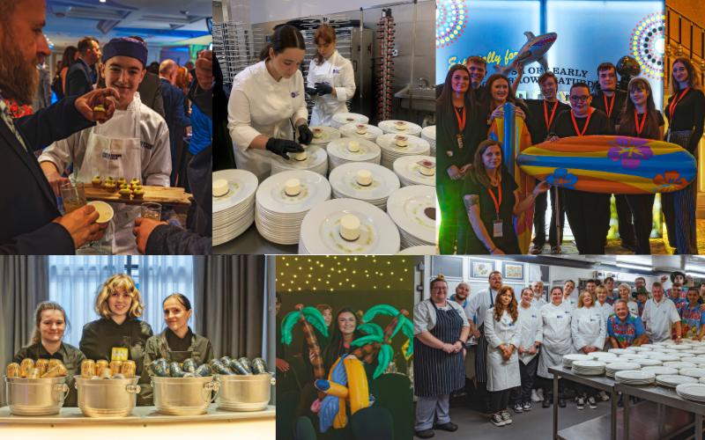
External Verification of students' work has come early this year, with a number taking place due to a soft hold being placed on several groups, owing to the previous resulting boycott. Those that have taken place have been very positive with only a few left to take place in October.
Those who follow the college on LinkedIn will have read about the Mobile Heat Pump Training Centre heading back to Shetland to undertake further training. The dedication of staff again went above and beyond, with the staff member having to battle through Storm Ashley to get there.
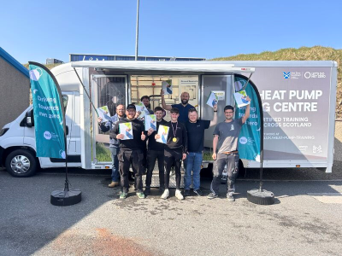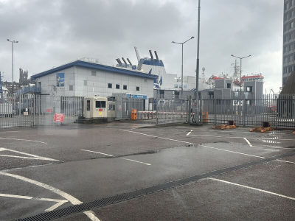
Police Scotland HND Social Science visit
PC Platt, Police Scotland Campus Police Officer, engaged with our HND Social Science Year 2 students to support their learning on the Scottish Criminal Justice system and the application of criminological theories. Criminology is a topic that is always popular with students and by supporting the learners to develop awareness of the complexities and multiple aspects of the justice system they will be better prepared for assessment and progression. PC Platt’s talk was thought provoking and created a chance for discussion relating to various aspects of the justice system, supporting communication and debating skills within the group. These skills are crucial not only in terms of assessment approaches, but also while considering meta skills and their application within the employment sector.
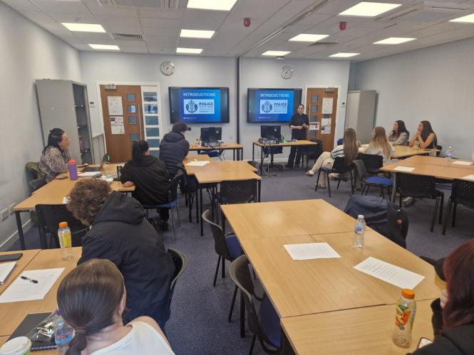
Inclusive Learning, ESOL and Counselling, Learning Hub.
The South Lanarkshire College Learning Hub is a dedicated space where students can find support to achieve their academic goals and overcome any learning barriers they may face. The Learning Hub team consists of a range of specialist staff; ELS (Extended Learning Support) Needs Assessors and a team of Support for Learning Assistants. The highly experienced team offer students general support to study and research effectively, offer a helping hand with essay and report writing, referencing and anything else that they might feel is a challenge.
Students can drop in to a dedicated room Monday to Thursday where the specialist team will be there to offer help and support. Full class sessions can be delivered on any of the above subjects, or on any topics that students may find difficult or be struggling with. The ELS team also provide needs assessment, targeted one to one support and make recommendations to help students achieve their goals.

